# Friday 11th Sep 2020 (VD & AD)

Set up after zombie apocalypse

Refamiliarising with the chamber

11.10 Rotary pump switched on

11:13 Turbo pump switched on

Pressure came down quick – system clean ;) (10E-6 mbar within 1h = no problem)

11:43 Chamber pressure 4 x10-6 mbar

14:51 p=5x10-7 mbar

15:30 MCT detector cooled

15:45 FTIR focusing mirror & detector alignment done Intensity 4.71

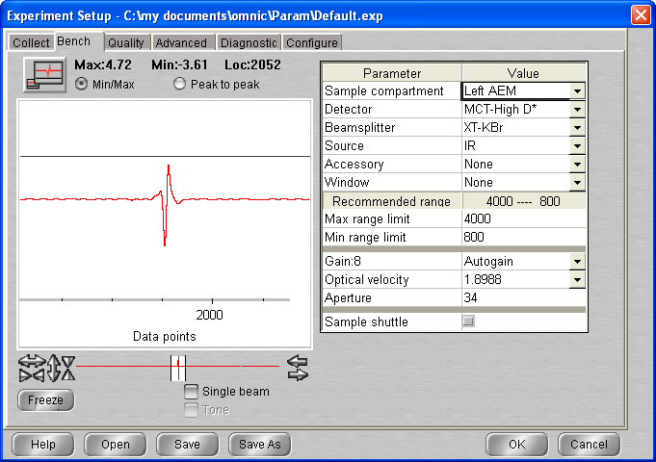

# Tuesday 15th Sep 2020 (VD & AD)

08:50 p=2x10-8 mbar; T=room temp

Clean substrate: turned the heater on (16V) and watched pressure rise until it reached a turning point at 3x10-6 mbar; held for 2-3 min and turned the heater off.

9:05 p = 5*10-8 mbar

9:15 p = 4 *10-8 mbar

9:17 Cryo compressor turned on

10:18 T = 103K / P = 5 * 10-9 mbar

10:20 Start cooling MCT detector

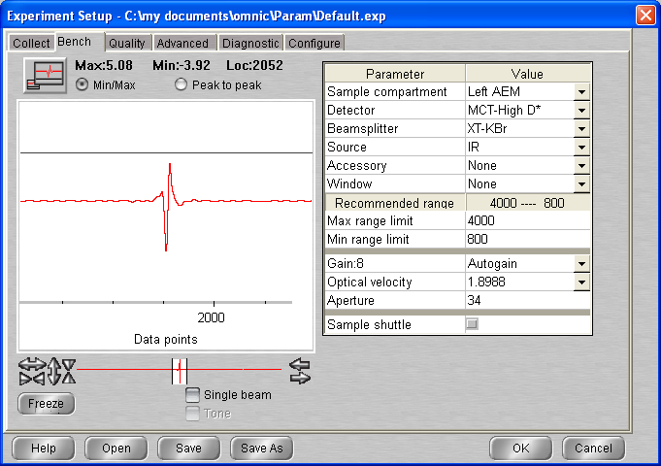

10:50 New rotary pump installed – connected to gas line

10:58 Pump (GL) turned on

11:00 T = 22.3 K (base temperature ?) P = 3.50 10-9 mbar

11:05 Deionised Water connected and F-P-T carried out x 3

13:15 Laser aligned signal 321 mV

14:22 P

**Background settings:**

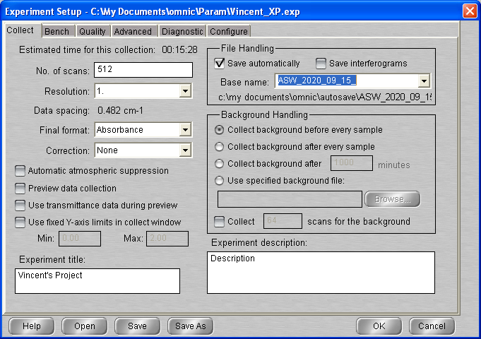

**Sample setting**

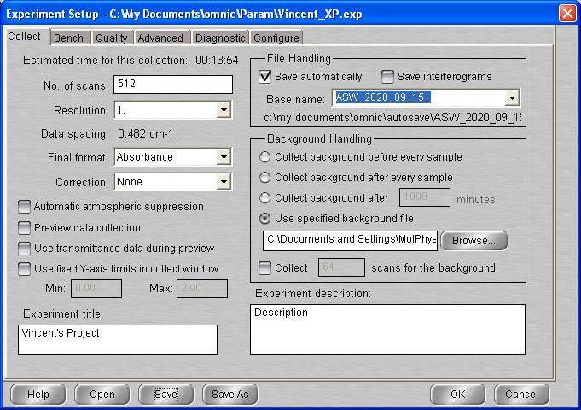

## Background scan(s) #1

**15:00 BG20200915_01**

Location : C:\Documents and Settings\MolPhys\My Documents\Vincent\2020_09_15  
512 scans 1 cm-1 res signal   
p = 6 x 10-10 mbar T = 20.5 K 🡪 Wrong values (check above for partial info)

## Deposition #1: H2O @ 22 K

15:30 20 min @ 1x10-7 mbar H2O

- Initial Temperature: 22.1K

- Initial pressure: 3*10-9 mbar

- Gas cell pressure: 9.5 torr

- Deposition pressure: 1 – 1.2 10E-7 mbar

- Laser signal: 325 mV

- Deposition time: 20 min

Something funny happened with the laser signal output – not much change on mV scale:



**16:13 ASW_2020_09_15_0001**

512 scans 1 cm-1 res signal 4.86  
p = 6.7 x 10-10 mbar T = 20.5 K

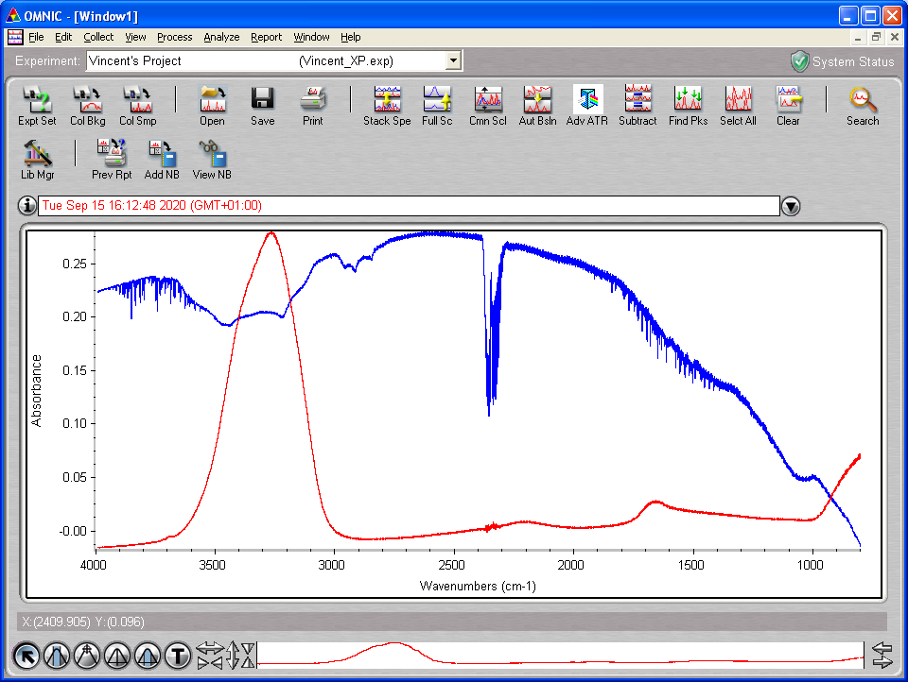

PID values changed p = 2.5 I = 5.0 d = 0.0

## Anneal to 130 K

17:06 Set Temperature 130K

Pressure chamber increased slightly (to monitor ?)

**17:32 ASW_2020_09_15_0002**

512 scans 1 cm-1 res signal 4.84  
p = ?? mbar T = 130 K

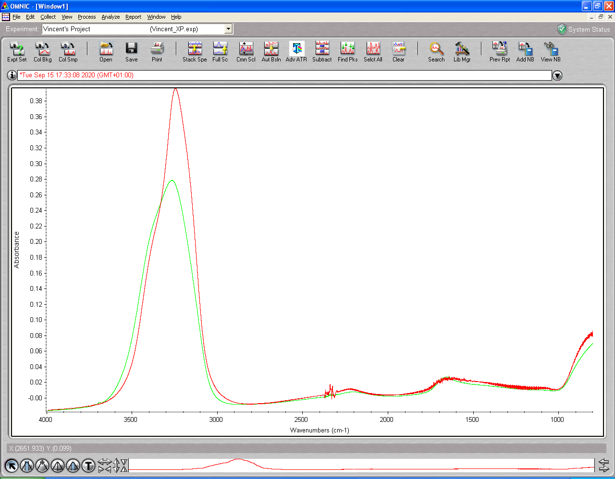

## Anneal to 140 K

17:50 Set Temperature 140K

**18:07 ASW_2020_09_15_0003**

512 scans 1 cm-1 res signal 4.84  
p = ??mbar T = 140 K

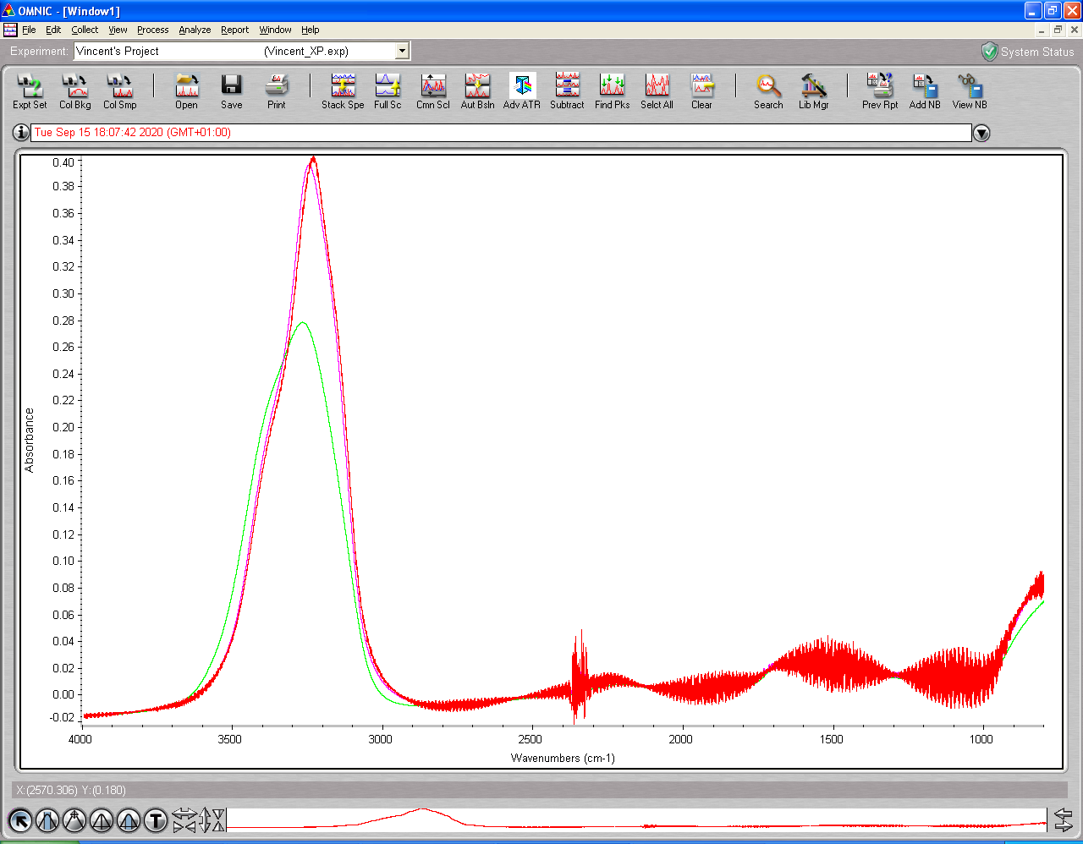

## Anneal to 160 K

18:25 Set Temperature 160K

**18:48 ASW_2020_09_15_0004 🡪 512 scan, resolution 1, signal: 4.90**

512 scans 1 cm-1 res signal 4.90  
p = ?? mbar T = 160 K

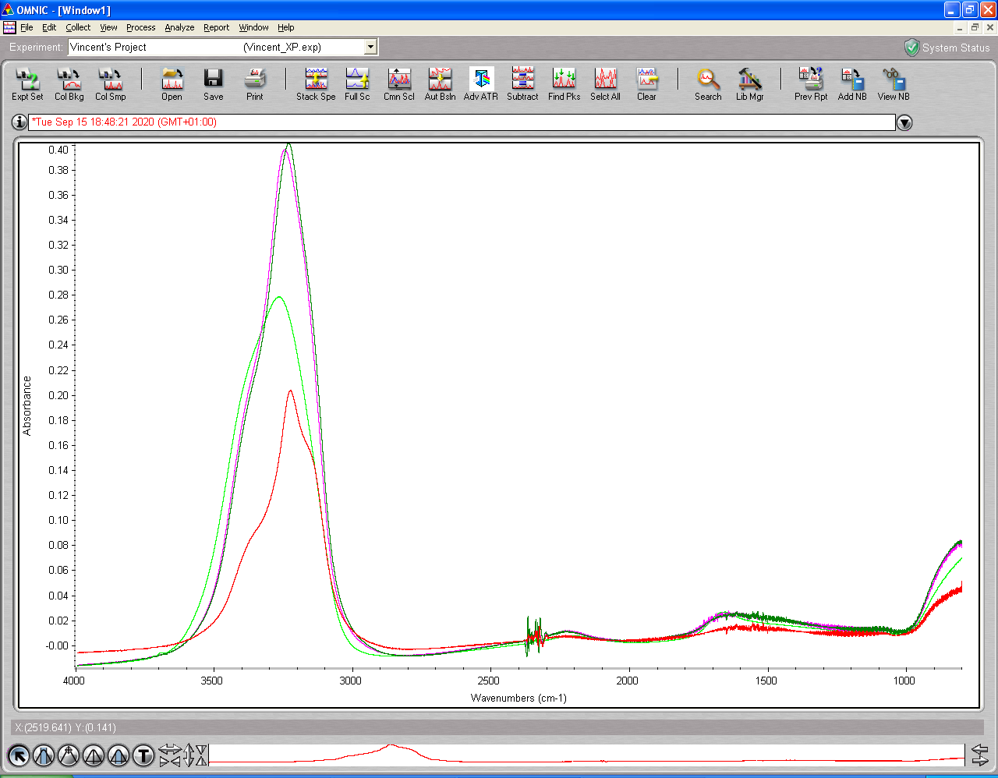

19:12 Heater set up manual 0.0 V and cryostat turned off.

Why is 160K such a drop in Absorbance?

Great day, ☺

# Wednesday 16th Sep 2020 (VD & AD)

09:00 p= 5x10-8 mbar

Heater on Auto to 300 K

09:30 MCT detector cooled; cryo on

**Plan for the day:**

* Deposit same as yesterday – 1-1.2 x 10-7 mbar for 20 min
* Scan at 20, 40, 60, 80 (see dangling bonds disappear), 100, 120, 130, 140, 160…
* If there is time, heat to 200 to remove water, cool to 130-160 and deposit

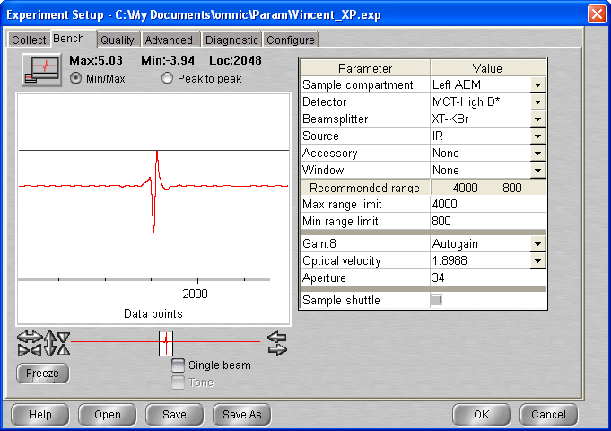

10:45 p=4x10-9 mbar T=70 K and dropping

## Background scan(s) #1

**11:04 BG20200916_01**

512 scans res = 1 cm-1 signal = 5.02  
p = 3.5 10-9 mbar T = 22.2 K

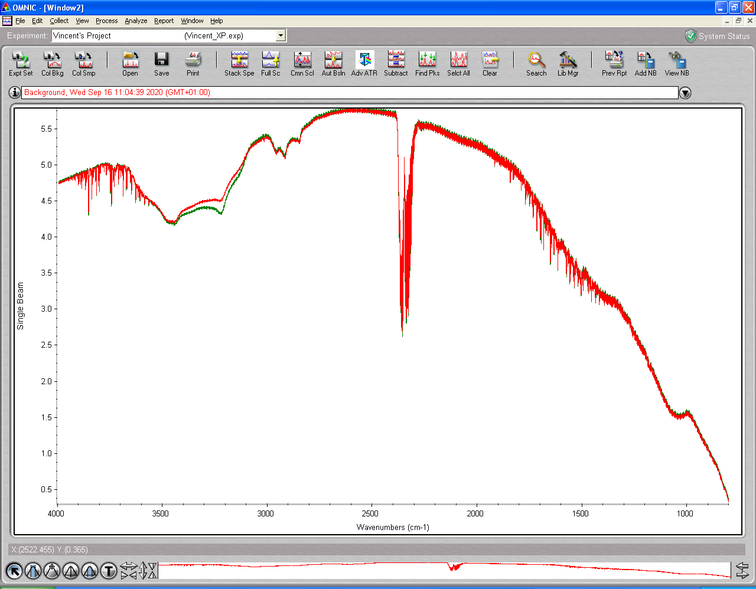

Red scan = 16/09 Green = 15/09 🡪 Less water, sample cleaner

## Deposition #2: H2O @ 22 K

12:00 20 min @ 1x10-7 mbar H2O

- Initial Temperature: 22.1 K

- Initial pressure: 3*10-9 mbar

- Initial gas cell pressure: 7.64 Torr

- Deposition pressure:

- Laser signal: 324.9 mV

- Deposition time: 20 min

- pressure after deposition 6.7*10-9 mbar

- final gas cell pressure = 6.4 Torr

**voltage/mV**

320.0

321.0

322.0

323.0

324.0

325.0

326.0

0

200

400

600

800

1000

1200

voltage/mV

Pressure spike!

**12:27** laser Off

**12:30 ASW_2020_09_16_0001**

512 scans 1 cm-1 res signal 4.94  
p = 6.9 x 10-9 mbar T = 22.1 K

**13:30 ASW_2020_09_16_0002 – repeat scan after 1 hour**

512 scans 1 cm-1 res signal 4.92  
p = 3.1 x 10-9 mbar T = 22.1 K

## Annealing to 40 K

**All files: ASW_2020_09_16_000# (see tables)** 512 scans; 1 cm-1 res

Temperature recorder as a function of time – EXCEL file: Temperature-steps-2020_09_16.xlsx

|  |  |  |  |  |  |  |
| --- | --- | --- | --- | --- | --- | --- |
| **time** | **File** | Start Temp/K | End Temp |  | p/mbar | signal |
| **14 :00** | **_0003** | 20 | 39.9 | Warm-up | 2x10-8 – 3.3x10-9 | 4.87 |
| **14 :15** | **_0004** | 39.9 | 40.0 | Warm-up | 3.3x10-9 | 4.87 |
| **14 :30** | **_0005** | 40.0 | 40.0 | isothermal | 3.0x10-9 | 4.87 |

-0.00

0.02

0.04

0.06

0.08

0.10

0.12

0.14

0.16

0.18

0.20

0.22

0.24

0.26

0.28

0.30

1000

1500

2000

2500

3000

3500

4000

Wavenumbers (cm-1)

20-40 K warm-up

22.1 K isothermal

22.1 K deposition

## Annealing to 60 K

|  |  |  |  |  |  |  |
| --- | --- | --- | --- | --- | --- | --- |
| **14 :45** | **_0006** | 40.0 | 59.8 | Warm-up | 4.8x10-8 – 4x10-9 |  |
| **15 :00** | **_0007** | 59.8 | 60 | Warm-up | 4.0x10-8 – 3.3x10-9 | 4.84 |
| **15 :15** | **_0008** | 60 | 60 | isothermal | 3.3x10-8 – x10-9 | 4.84 |

## Annealing to 80 K

|  |  |  |  |  |  |  |
| --- | --- | --- | --- | --- | --- | --- |
| **15 :30** | **_0009** | 60 | ## | Warm-up | 4.8x10-8 – 4x10-9 |  |
| **15 :45** | **_0010** | ## | 80 | Warm-up | 4.0x10-8 – 3.3x10-9 | 4.84 |
| **16 :00** | **_0011** | 80 | 80 | isothermal | 3.3x10-8 – x10-9 | 4.84 |

## Annealing to 100 K

|  |  |  |  |  |  |  |
| --- | --- | --- | --- | --- | --- | --- |
| **16:15** | **_0012** | 80 | ## | Warm-up | 4.8x10-8 – 4x10-9 |  |
| **16 :30** | **_0013** | ## | 100 | Warm-up | 4.0x10-8 – 3.3x10-9 | 4.84 |
| **16 :45** | **_0014** | 100 | 100 | isothermal | 3.3x10-8 – x10-9 | 4.84 |

## Annealing to 120 K

|  |  |  |  |  |  |  |
| --- | --- | --- | --- | --- | --- | --- |
| **17 :00** | **_0015** | 100 | ## | Warm-up | 4.8x10-8 – 4x10-9 |  |
| **17 :15** | **_0016** | ## | 120 | Warm-up | 4.0x10-8 – 3.3x10-9 | 4.84 |
| **17 :30** | **_0017** | 120 | 120 | isothermal | 3.3x10-8 – x10-9 | 4.84 |

## Annealing to 130 K

|  |  |  |  |  |  |  |
| --- | --- | --- | --- | --- | --- | --- |
| **17 :45** | **_0018** | 120 | ## | Warm-up | 4.8x10-8 – 4x10-9 |  |
| **18 :00** | **_0019** | ## | 130 | Warm-up | 4.0x10-8 – 3.3x10-9 | 4.84 |
| **18 :15** | **_0020** | 130 | 130 | isothermal | 3.3x10-8 – x10-9 | 4.84 |

## Annealing to 140 K

|  |  |  |  |  |  |  |
| --- | --- | --- | --- | --- | --- | --- |
| **18:30** | **_0021** | 130 | ## | Warm-up | 4.8x10-8 – 4x10-9 |  |
| **18 :45** | **_0022** | ## | 140 | Warm-up | 4.0x10-8 – 3.3x10-9 | 4.84 |
| **19 :00** | **_0023** | 140 | 140 | isothermal | 3.3x10-8 – x10-9 | 4.84 |

## Annealing to 160 K

|  |  |  |  |  |  |  |
| --- | --- | --- | --- | --- | --- | --- |
| **19 :15** | **_0024** | 140 | ## | Warm-up | 4.8x10-8 – 4x10-9 |  |
| **19 :30** | **_0025** | ## | 160 | Warm-up | 4.0x10-8 – 3.3x10-9 | 4.84 |
| **19 :45** | **_0026** | 160 | 160 | isothermal | 3.3x10-8 – x10-9 | 4.84 |

## Annealing to 180 K

|  |  |  |  |  |  |  |
| --- | --- | --- | --- | --- | --- | --- |
| **20 :00** | **_0027** | 160 | ## | Warm-up | 4.8x10-8 – 4x10-9 |  |
| **20 :15** | **_0028** | ## | 180 | Warm-up | 4.0x10-8 – 3.3x10-9 | 4.84 |
| **20 :30** | **_0029** | 180 | 180 | isothermal | 3.3x10-8 – x10-9 | 4.84 |

## Annealing to 200 K

|  |  |  |  |  |  |  |
| --- | --- | --- | --- | --- | --- | --- |
| **20 :45** | **_0030** | 180 | ## | Warm-up | 4.8x10-8 – 4x10-9 |  |
| **21 :00** | **_0031** | ## | 200 | Warm-up | 4.0x10-8 – 3.3x10-9 | 4.84 |

To complete 🡪 P wrongs

# Thursday 17th Sep 2020 (VD & AD)

08:48 p= 2.25x10-8 mbar

Heater on Man at 0V 🡪 T = 275.4

08:50 Cryo on

9:07 Laser turned on

9:26 MCT Detector cooled (ice was growing on the edges of the opening and I put the tape on top of it, is it an issue?)

10:12 T = 22K 🡪 Did wrong manip (put heater on auto) 🡪 T increase to 44K (quick flash heat) 🡪 put back heater on Man V = 0.0

10:42 Base P = 2.4 10E-9 Base T = 21.7

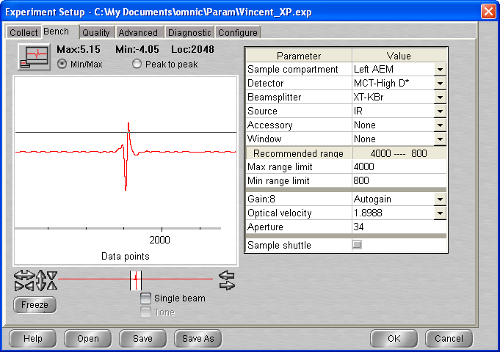

## Background scan(s) #1

**11:00 BG20200917_01**

512 scans res = 1 cm-1 signal = 5.15  
p = 2.3 10-9 mbar T = 21.7 K

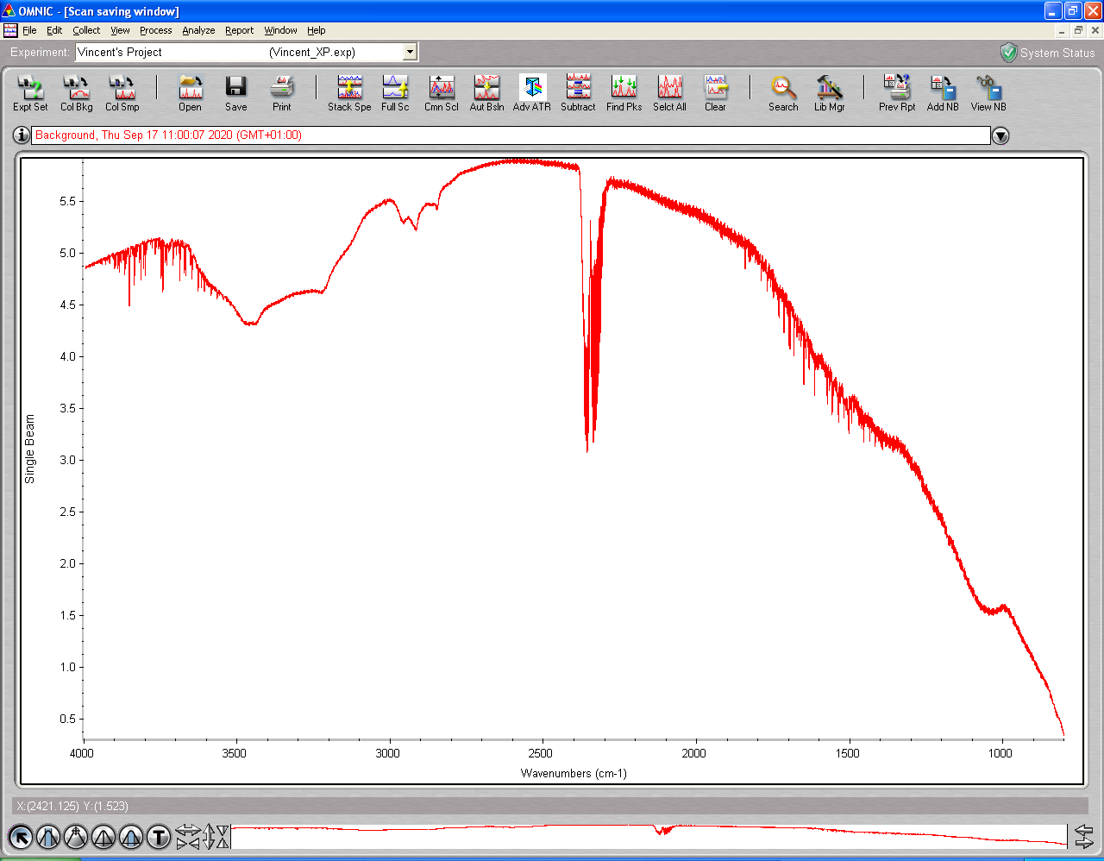

11 :20 **Refill gas cell procedure (0.642 Torr initial pressure)**

**Gas cell valve open**

**Pump valve close**

**{...}**

**Final Pressure : 0.759 Torr**

11:33 Head rotated Laser signal = 325.4 mV

## Deposition #3: H2O @ 22 K

11:40 2 min @ 1x10-6 mbar H2O

- Initial Temperature: 21.7 K

- Initial pressure: 2.2 10-9 mbar

- Initial gas cell pressure: 7.56 Torr

- Deposition pressure: 1.04 10-6 – 9.8 10-7

- Laser signal: 325.4 mV

- Deposition time: 2 min

- pressure after deposition 8.9*10-9 mbar

- final gas cell pressure = 6.32 Torr



**11:47** laser Off

11:48 Head rotated

**11:52 ASW_2020_09_17_0001**

512 scans 1 cm-1 res signal 5.27  
p = 5.7 x 10-9 mbar T = 21.7 K

**12:08 ASW_2020_09_17_0002**

512 scans 1 cm-1 res signal 5.26  
p = 3.5 x 10-9 mbar T = 21.7 K

13 :17 P = 2.3 10-9 mbar T = 21.6 K

## Annealing to 40 K

**All files: ASW_2020_09_17_000# (see tables)** 512 scans; 1 cm-1 res

Temperature recorder as a function of time – EXCEL file: Temperature-steps-2020_09_17.xlsx

|  |  |  |  |  |  |  |
| --- | --- | --- | --- | --- | --- | --- |
| **time** | **File** | Start Temp/K | End Temp |  | p/mbar | signal |
| **14 :00** | **_0003** | 21.6 | 39.9 | Warm-up | 3x10-8 – 2.5x10-9 |  |
| **14 :15** | **_0004** | 39.9 | 40.0 | Warm-up | 2.5x10-9 |  |
| **14 :30** | **_0005** | 40.0 | 40.0 | isothermal | 2.3x10-9 | 5.24 |

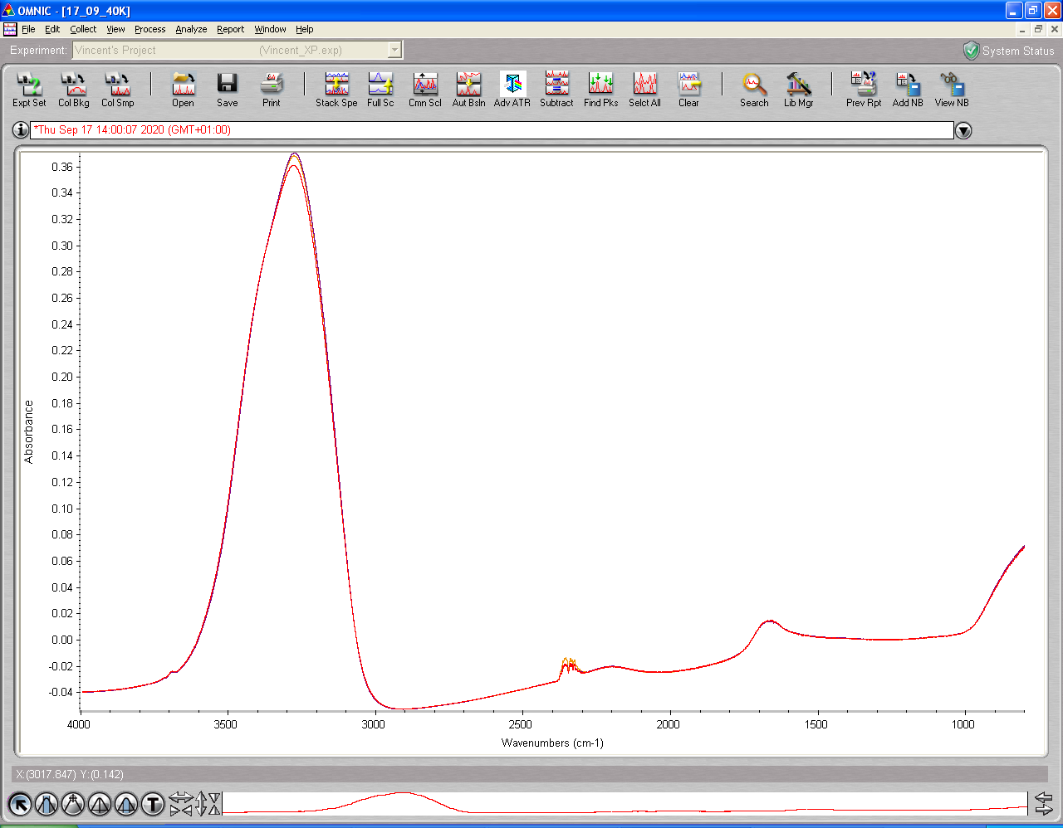

## Annealing to 60 K

|  |  |  |  |  |  |  |
| --- | --- | --- | --- | --- | --- | --- |
| **14 :45** | **_0006** | 40.0 | 59.8 | Warm-up | 8x10-8 – 3.6x10-9 |  |
| **15 :00** | **_0007** | 59.8 | 60 | Warm-up | 3.1x10-9 | 5.23 |
| **15 :15** | **_0008** | 60 | 60 | isothermal | 2.7 x10-9 | 5.22 |

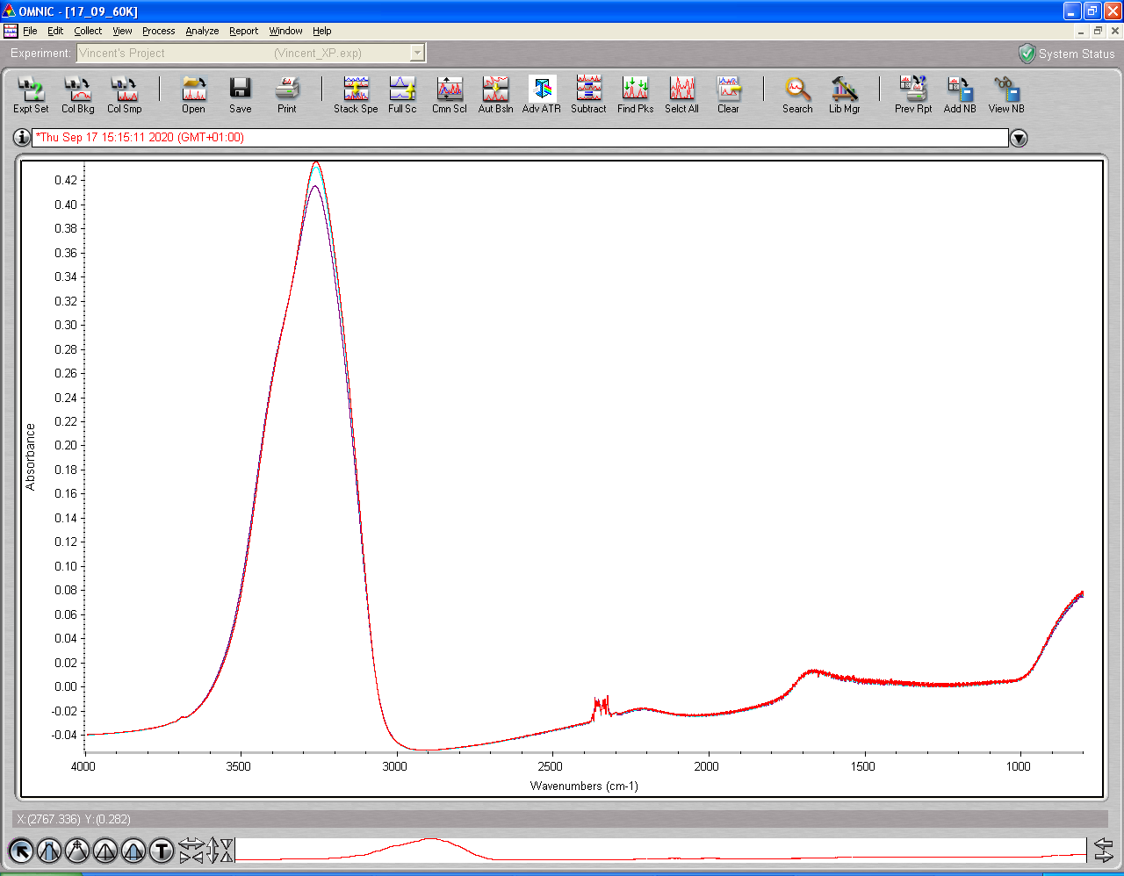

## Annealing to 80 K

|  |  |  |  |  |  |  |
| --- | --- | --- | --- | --- | --- | --- |
| **15 :30** | **_0009** | 60 | 79.7 | Warm-up | 2.5x10-8 – 3.1x10-9 | 5.21 |
| **15 :45** | **_0010** | 79.8 | 79.9 | Warm-up | 2.9 x10-9 | 5.21 |
| **16 :00** | **_0011** | 79.9 | 80 | isothermal | 2.8 x10-9 | 5.21 |

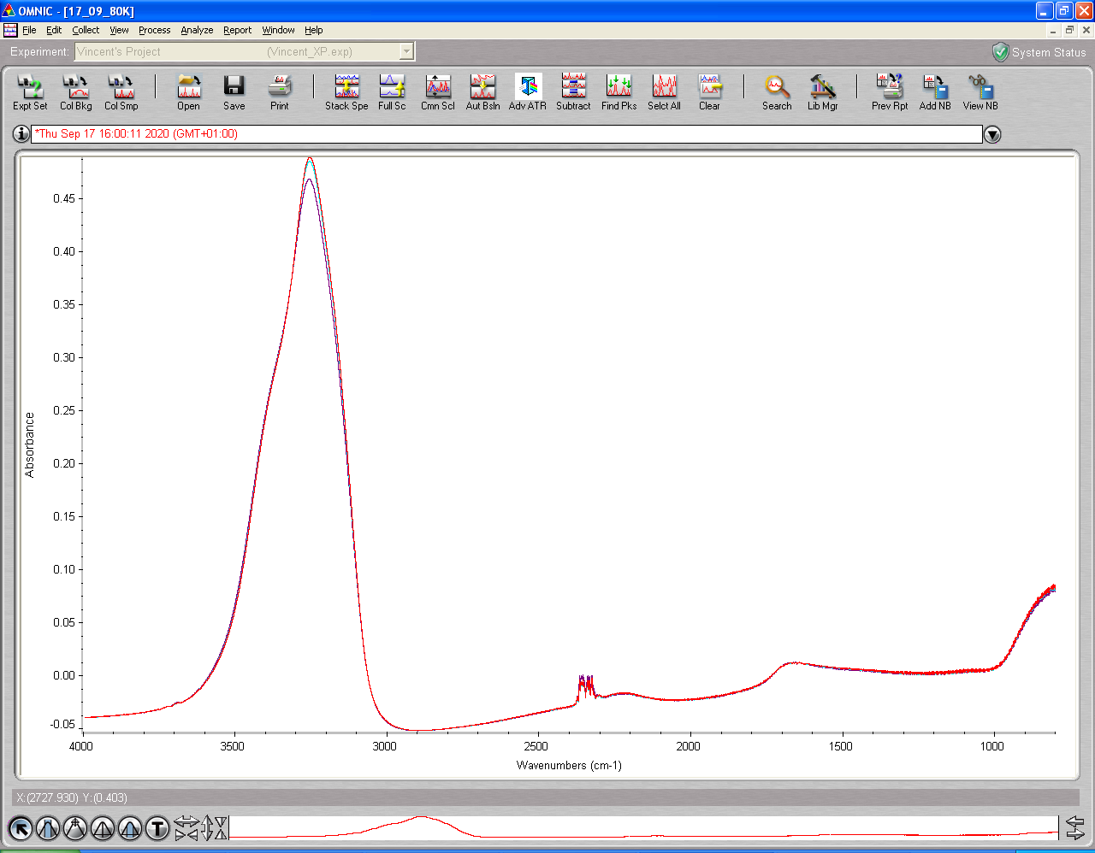

## Annealing to 100 K

|  |  |  |  |  |  |  |
| --- | --- | --- | --- | --- | --- | --- |
| **16:15** | **_0012** | 80 | 99.8 | Warm-up | 5.7x10-8 – 4.1x10-9 |  |
| **16 :30** | **_0013** | 99.9 | 100 | Warm-up | 3.6 x10-9 | 5.20 |
| **16 :45** | **_0014** | 100 | 100 | isothermal | 3.0 x10-9 | 5.20 |

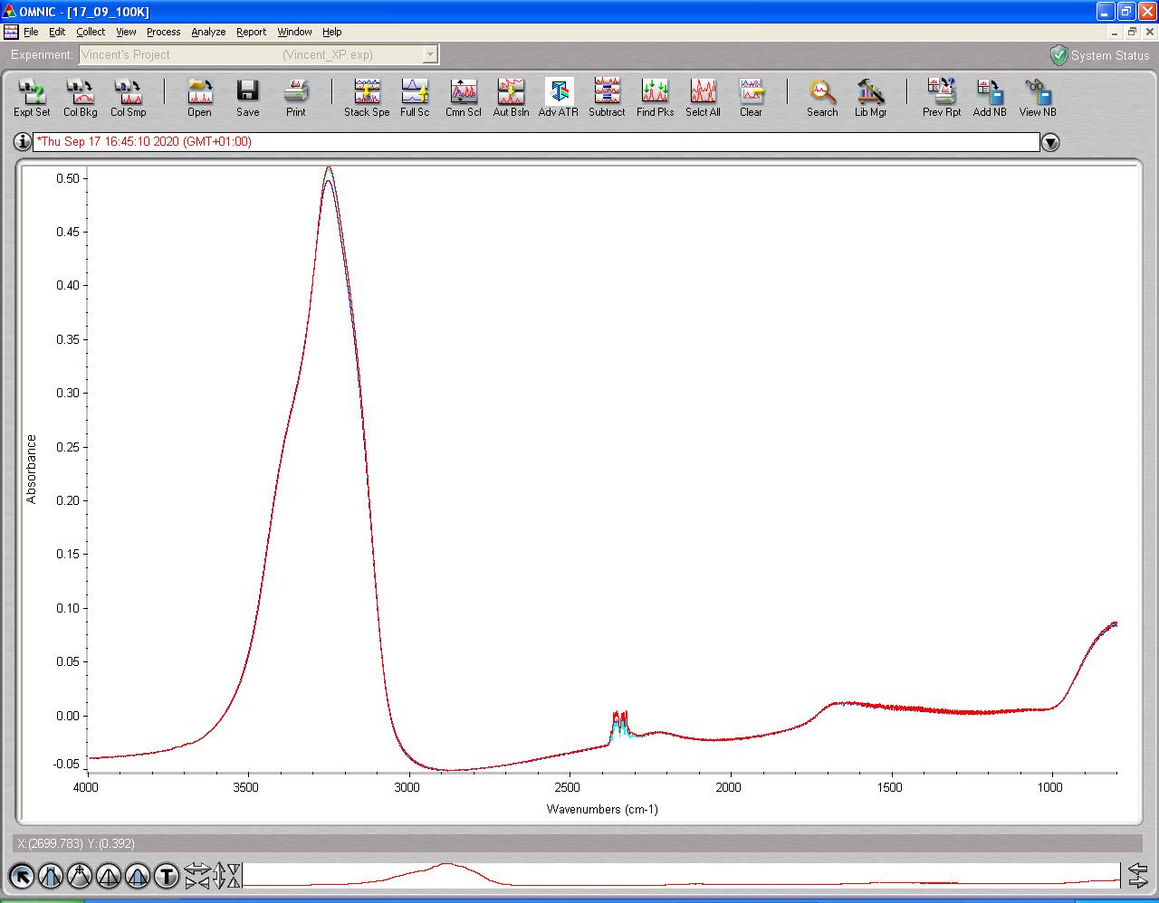

## Annealing to 120 K

|  |  |  |  |  |  |  |
| --- | --- | --- | --- | --- | --- | --- |
| **17 :00** | **_0015** | 100 | 119.7 | Warm-up | 7.7x10-8 – 4.8x10-9 |  |
| **17 :15** | **_0016** | 119.7 | 120 | Warm-up | 3.6 x10-9 | 5.19 |
| **17 :30** | **_0017** | 120 | 120 | isothermal | 3.1 x10-9 | 5.19 |

## Annealing to 130 K

|  |  |  |  |  |  |  |
| --- | --- | --- | --- | --- | --- | --- |
| **17 :45** | **_0018** | 120 | 129.8 | Warm-up | 2.6x10-8 – 7.7x10-9 |  |
| **18 :00** | **_0019** | 129.8 | 130 | Warm-up | 7.1x10-8 | 5.18 |
| **18 :15** | **_0020** | 130 | 130 | isothermal | 7.0x10-8 | 5.17 |

## Annealing to 140 K

|  |  |  |  |  |  |  |
| --- | --- | --- | --- | --- | --- | --- |
| **18:30** | **_0021** | 130 | 139.8 | Warm-up | 8x10-8 – 5.9x10-8 |  |
| **18 :45** | **_0022** | 139.8 | 140 | Warm-up | 5.3x10-8 | 5.17 |
| **19 :00** | **_0023** | 140 | 140 | isothermal | 4.6x10-8 | 5.17 |

## Annealing to 160 K

|  |  |  |  |  |  |  |
| --- | --- | --- | --- | --- | --- | --- |
| **19 :15** | **_0024** | 140 | 159.7 | Warm-up | 1.1x10-7 – 3.4x10-6 | 5.15 |
| **19 :30** | **_0025** | 159.8 | 160 | Warm-up | 2.9x10-6 | 5.16 |
| **19 :45** | **_0026** | 160 | 160 | isothermal | 1.2x10-6 | 5.04 |

## Annealing to 180 K

|  |  |  |  |  |  |  |
| --- | --- | --- | --- | --- | --- | --- |
| **20 :00** | **_0027** | 160 | ## | Warm-up | ## | 5.02 |
| **20 :15** | **_0028** | ## | 180 | Warm-up |  | 5.01 |

20:30 Gas cell valve open for pumping

20:30 Heater 0.0 V

20:30 Cryo off

# Monday 21th Sep 2020 (VD)

08:42 p= x10-8 mbar; T=room temp (278.5)

Clean substrate: turned the heater on (16V) and watched pressure rise until it reached a turning point at ~ 10-7 mbar; held for 2-3 min and turned the heater off.

8:51 p = 2.1*10-8 mbar

8:55 p = 1.7 *10-8 mbar

8:55 Cryo-on, Laser on

9:34 MCT cooled

## Background scan(s) #1

**10:56 BG20200921_01**

512 scans res = 1 cm-1 signal = 5.11  
 p = 1.3 * 10-9 mbar T = 21.8K

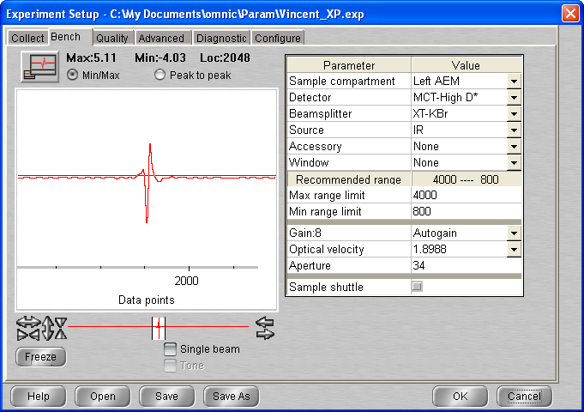

11 :20 **Refill gas cell procedure (GAS CELL LEFT PUMPING OVER THE WEEK-END)**

**Gas cell valve open**

**Pump valve close**

**{...}**

**Final Pressure : 0.73 Torr**

**11:30 Head rotated laser signal = 325.3**

## Deposition #4: H2O @ 22 K

12:00 3h20 @ 1x10-8 mbar H2O

- Initial Temperature: 21.8 K

- Initial pressure: 1.3 10-9 mbar

- Initial gas cell pressure: 6.92 Torr

- Initial gas cell pressure: 5.87 Torr

- Deposition pressure: 1 * 10-8 mbar

- Laser signal: 325.3 mV

- Deposition time: 3h20 min

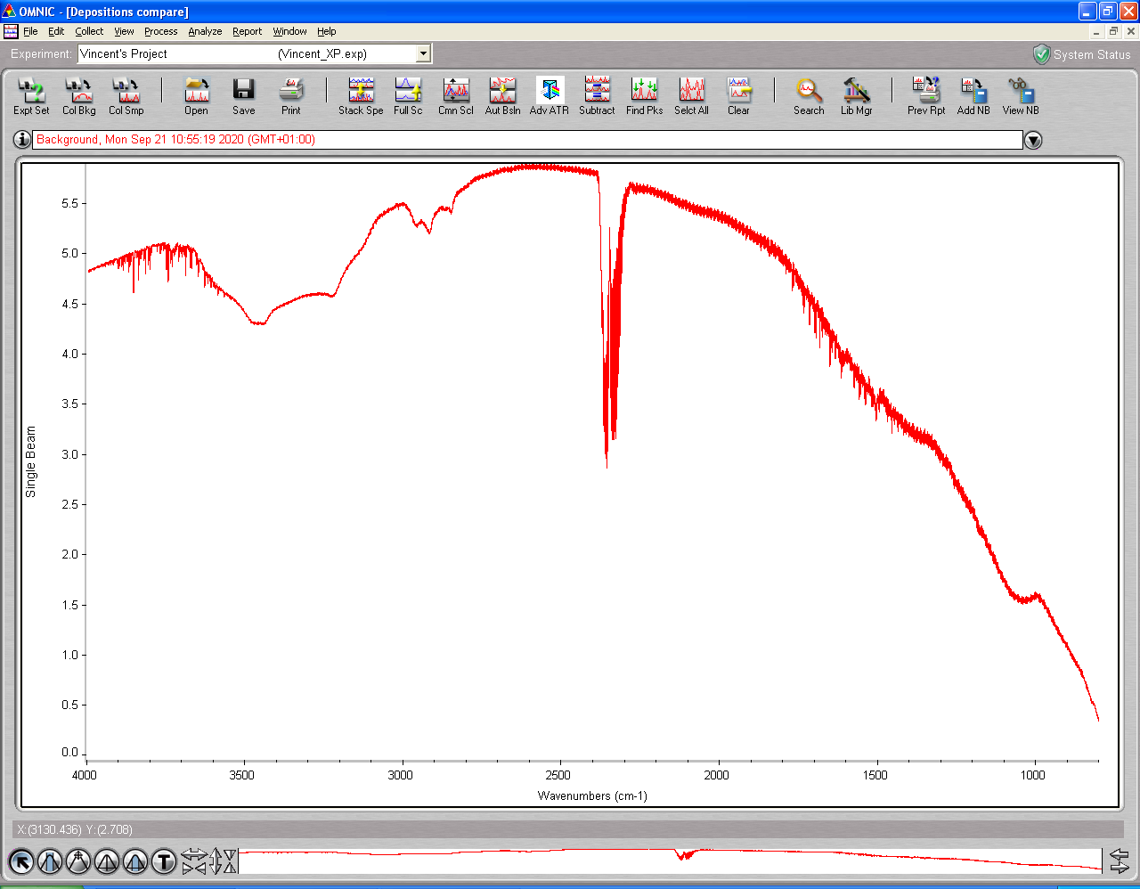

15:20 Needle valve closed – laser turned off

15:22 P = 2.1 * 10-9 mbar T = 21.8

**15:25 ASW_2020_09_21_0001**

512 scans 1 cm-1 res signal 5.10  
p = 1.9 x 10-9 mbar T = 21.8 K

**15:57 ASW_2020_09_21_0002**

512 scans 1 cm-1 res signal 5.08  
p = 1.3 x 10-9 mbar T = 21.8 K

## Annealing to 40 K

**All files: ASW_2020_09_21_000# (see tables)** 512 scans; 1 cm-1 res

Temperature recorder as a function of time – EXCEL file: Temperature-steps-2020_09_21.xlsx

|  |  |  |  |  |  |  |
| --- | --- | --- | --- | --- | --- | --- |
| **time** | **File** | Start Temp/K | End Temp |  | p/mbar | signal |
| **16 :30** | **_0003** | 21.7 | 39.9 | Warm-up |  |  |
| **16 :45** | **_0004** | 39.9 | 40.1 | Warm-up |  | 5.06 |
| **17 :00** | **_0005** | 40.1 | 40.0 | isothermal |  | 5.06 |

## Annealing to 60 K

|  |  |  |  |  |  |  |
| --- | --- | --- | --- | --- | --- | --- |
| **17:15** | **_0006** | 40.0 |  | Warm-up |  | 5.05 |
| **17 :30** | **_0007** |  | 60 | Warm-up |  | 5.06 |
| **17 :45** | **_0008** | 60 | 60 | isothermal |  | 5.05 |

## Annealing to 80 K

|  |  |  |  |  |  |  |
| --- | --- | --- | --- | --- | --- | --- |
| **18 :00** | **_0009** | 60 | ## | Warm-up |  | 5.04 |
| **18 :15** | **_0010** | ## | 80 | Warm-up |  | 5.04 |
| **18 :30** | **_0011** | 80 | 80 | isothermal |  | 5.03 |

## Annealing to 100 K

|  |  |  |  |  |  |  |
| --- | --- | --- | --- | --- | --- | --- |
| **18:45** | **_0012** | 80 | 99.8 | Warm-up |  | 5.03 |
| **19:00** | **_0013** | 99.9 | 100 | Warm-up |  | 5.03 |
| **19 :15** | **_0014** | 100 | 100 | isothermal |  | 5.01 |

## Annealing to 120 K

|  |  |  |  |  |  |  |
| --- | --- | --- | --- | --- | --- | --- |
| **19 :30** | **_0015** | 100 | 119.7 | Warm-up |  | 5.01 |
| **19 :45** | **_0016** | 119.7 | 120 | Warm-up |  |  |
| **20 :00** | **_0017** | 120 | 120 | isothermal |  | 5.01 |

## Annealing to 130 K

|  |  |  |  |  |  |  |
| --- | --- | --- | --- | --- | --- | --- |
| **20 :15** | **_0018** | 120 |  | Warm-up |  | 5.01 |
| **20 :30** | **_0019** | 129.8 | 130 | Warm-up |  | 5.01 |
| **20 :45** | **_0020** | 130 | 130 | isothermal |  | 5.01 |

## Annealing to 140 K

|  |  |  |  |  |  |  |
| --- | --- | --- | --- | --- | --- | --- |
| **21:00** | **_0021** | 130 | 139.8 | Warm-up |  | 5.01 |
| **21 :15** | **_0022** | 139.8 | 140 | Warm-up |  | 5.02 |
| **21 :30** | **_0023** | 140 | 140 | isothermal |  | 5.01 |

## Annealing to 160 K

|  |  |  |  |  |  |  |
| --- | --- | --- | --- | --- | --- | --- |
| **21 :45** | **_0024** | 140 | 159.7 | Warm-up |  | 5.01 |
| **22 :00** | **_0025** | 159.8 | 160 | Warm-up |  | 4.96 |
| **22 :15** | **_0026** | 160 | 160 | isothermal |  | 4.97 |

## Annealing to 180 K

|  |  |  |  |  |  |  |
| --- | --- | --- | --- | --- | --- | --- |
| **22 :30** | **_0027** | 160 | ## | Warm-up | ## | 4.98 |
| **22 :45** | **_0028** | ## | 180 | Warm-up |  | 4.96 |

23 :00 Heater turned off

23 :05 Cryo turned of

# Thursday 24th Sep 2020 (VD)

9:25 T = 278.5 P = 7.80 * 10-9

9:30 Cryo turned on

10:21 T = 136.7 P = 1.9 * 10-9

11:43 T = 21.7 K P = 9.8 10-10

12:04 T set up 100K

12:12 MCT detector cooled / Laser turned on

12:50 T= 100K P= 1.9 * 10 -9

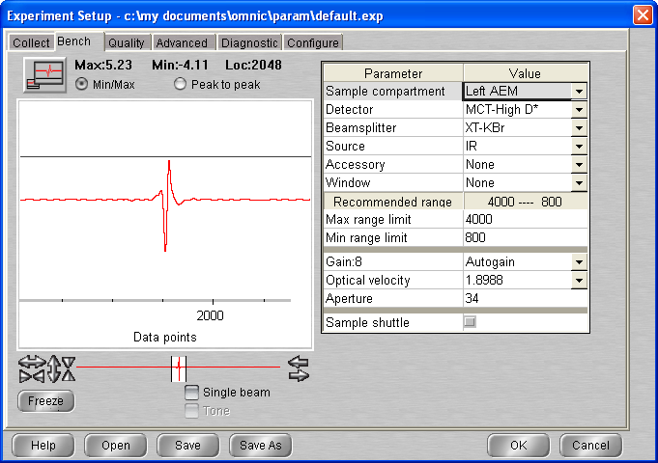

## Background scan(s) #1

**13:40 BG20200924_01**

512 scans res = 1 cm-1 signal = 5.23  
p = 1.5 10-9 mbar T = 100.0 K

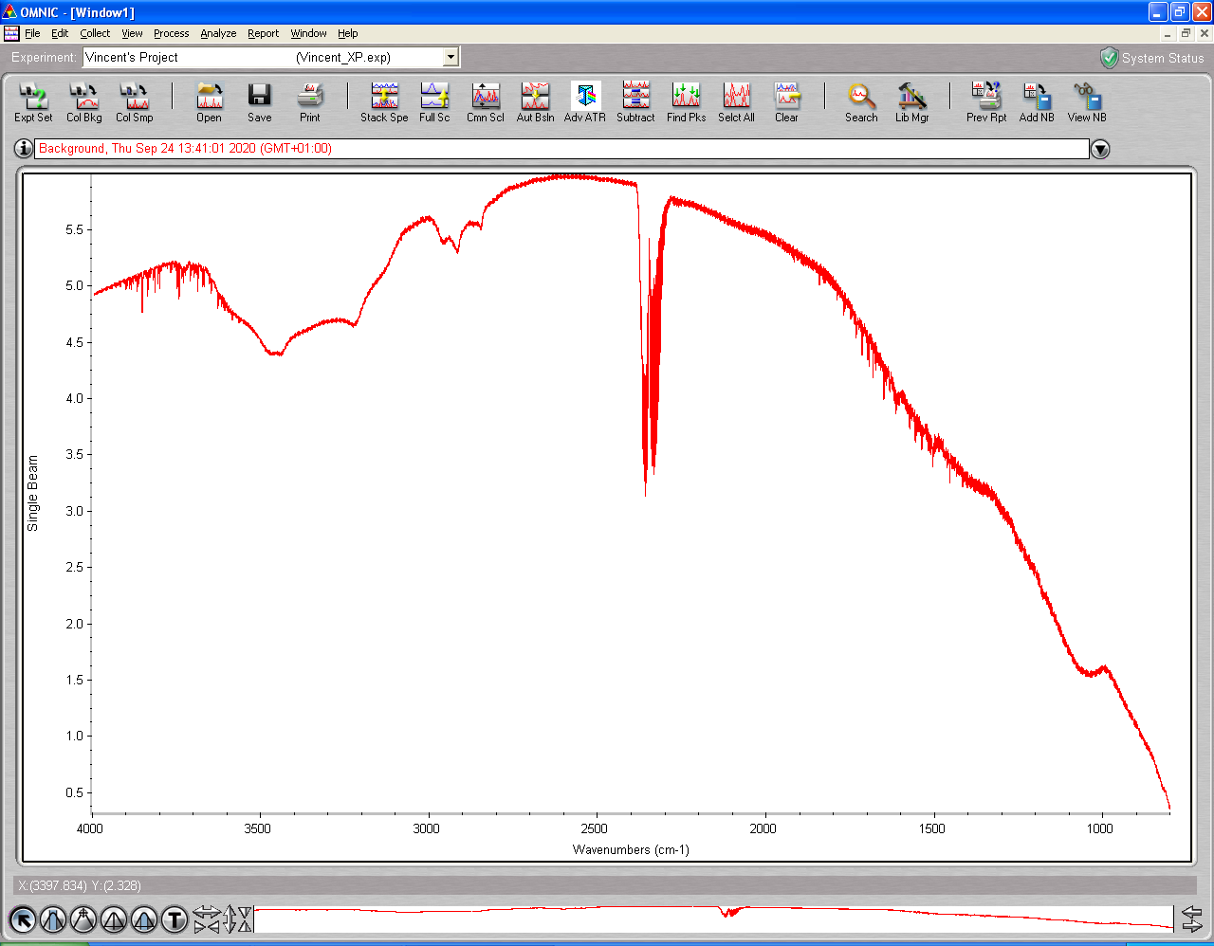

11 :20 **Refill gas cell procedure (0.578 Torr initial pressure)**

**Pump valve close**

**{...}**

**Final Pressure : 0.753 Torr**

11:33 Head rotated Laser signal = 325.2 mV

## Deposition #5: H2O @ 100K

11:40 20 min @ 1x10-7 mbar H2O

- Initial Temperature: 100K

- Initial pressure: 1.5 10-9 mbar

- Initial gas cell pressure: 7.53 Torr

- Deposition pressure: 1.05 10-7 – 1.1 10-7

- Laser signal: 325 mV

- Deposition time: 20 min

- pressure after deposition 6.7*10-9 mbar

- final gas cell pressure = 6.64 Torr



**14:32** laser Off

14:32 Head rotated

**14:49 ASW_2020_09_24_0001**

512 scans 1 cm-1 res signal 5.34  
p = 2.7 x 10-9 mbar T = 100.0 K

**15:05 ASW_2020_09_24_0002**

512 scans 1 cm-1 res signal 5.26  
p = T = 100 K

## Annealing to 120 K

|  |  |  |  |  |  |  |
| --- | --- | --- | --- | --- | --- | --- |
| **16 :00** | **_0003** | 100 | 119.7 | Warm-up |  |  |
| **16 :15** | **_0004** | 119.7 | 120 | Warm-up |  | 5.30 |
| **16 :30** | **_0005** | 120 | 120 | isothermal |  | 5.30 |

## Annealing to 130 K

|  |  |  |  |  |  |  |
| --- | --- | --- | --- | --- | --- | --- |
| **16 :45** | **_0006** | 120 |  | Warm-up |  | 5.30 |
| **17 :00** | **_0007** |  | 130 | Warm-up |  | 5.29 |
| **17 :15** | **_0008** | 130 | 130 | isothermal |  |  |

## Annealing to 140 K

|  |  |  |  |  |  |  |
| --- | --- | --- | --- | --- | --- | --- |
| **17:30** | **_0009** | 130 | 139.8 | Warm-up |  |  |
| **17 :45** | **_0010** | 139.8 | 140 | Warm-up |  |  |
| **18 :00** | **_0011** | 140 | 140 | isothermal |  | 5.27 |

## Annealing to 150 K

|  |  |  |  |  |  |  |
| --- | --- | --- | --- | --- | --- | --- |
| **18:15** | **_0012** | 140 |  | Warm-up |  |  |
| **18 :30** | **_0013** |  | 150 | Warm-up |  |  |
| **18 :45** | **_0014** | 150 | 150 | isothermal |  | 5.26 |
| **19 :00** | **_0015** | 150 | 150 | isothermal |  | 5.25 |
| **19 :15** | **_0016** | 150 | 150 | isothermal | ~3.4 * 10-7 | 5.24 |
| **19:30** | **_0017** | 150 | 150 | Isothermal | ~3.2 * 10-7 | 5.23 |
| **19:45** | **_0018** | 150 | 150 | Isothermal | ~3.1 * 10-7 | 5.23 |
| **20:00** | **_0019** | 150 | 150 | Isothermal | ~3.1 * 10-7 | 5.22 |
| **20:15** | **_0020** | 150 | 150 | Isothermal | ~3.0 * 10-7 | 5.20 |
| **20:30** | **_0021** | 150 | 150 | Isothermal | ~2.9 * 10-7 | 5.19 |
| **20:45** | **_0022** | 150 | 150 | Isothermal | ~2.7 * 10-7 | 5.18 |
| **21:00** | **_0023** | 150 | 150 | Isothermal | ~2.4 * 10-7 | 5.17 |

## Annealing to 160 K

|  |  |  |  |  |  |  |
| --- | --- | --- | --- | --- | --- | --- |
| **21 : 15** | **_0024** |  |  | Warm-up |  |  |
| **21 :30** | **_0025** |  | 160 | Warm-up |  | 5.10 |

# Monday 28th Sep 2020 (VD)

9:18 T = 278.4 P = 5.10 * 10-9

9:18 Cryo turned on

9:25 Laser On

9:44 MCT Detector cooled

10:06 T = 133.2 P = 1.5 10e-9

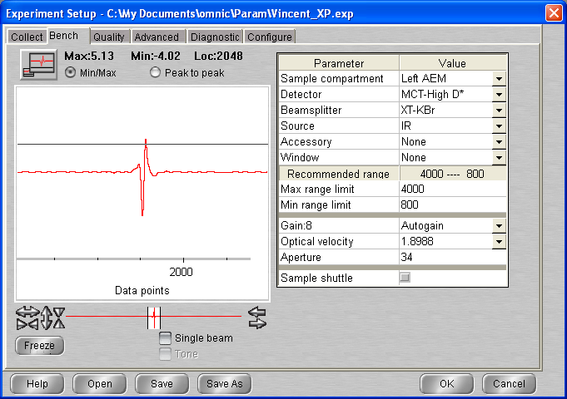

## Background scan(s) #1

**11:02 BG20200928_01**

512 scans res = 1 cm-1 signal = 5.13  
p = 7 10-10 mbar T = 21.7 K

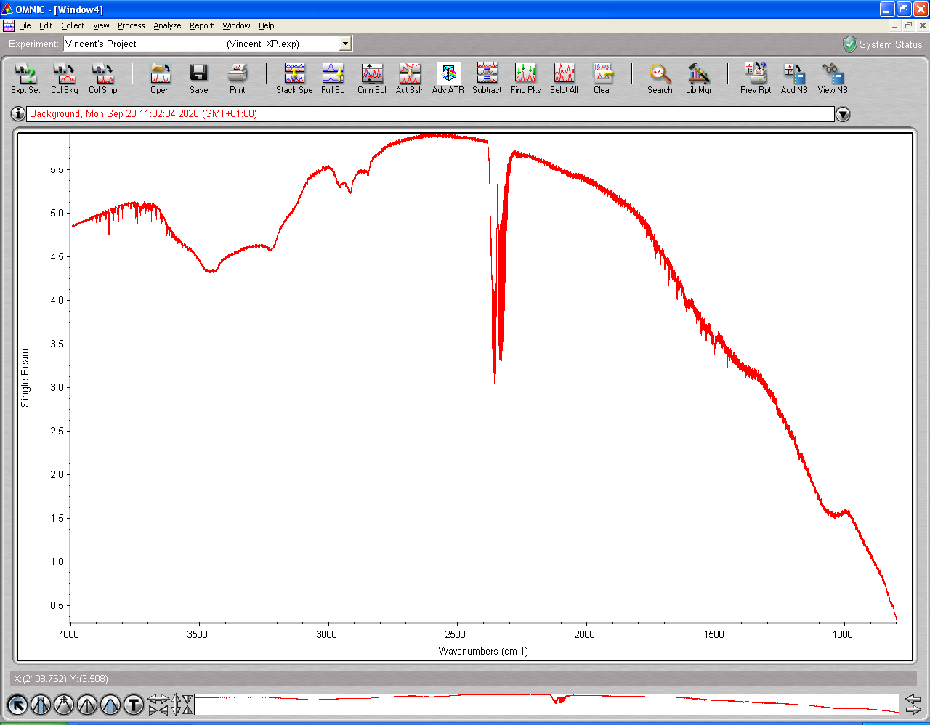

11 :25 **Refill gas cell procedure (0.659 Torr initial pressure)**

**Pump valve close**

**{...}**

**Final Pressure : 0.755 Torr**

11:30 Head rotated Laser signal = 325.9 mV

## Deposition #6: H2O @ 22K

11:40 20 min @ 1x10-7 mbar H2O

- Initial Temperature: 21.6K

- Initial pressure: 7 * 10-10 mbar

- Initial gas cell pressure: 7.54 Torr

- Deposition pressure: 1.01-1.11 * 10-7 mbar

- Laser signal: 326.2 mV

- Deposition time: 20 min

- pressure after deposition: 9.0 * 10-9 mbar

- final gas cell pressure = 0.636 Torr

11:55 Laser turned off

12:00 Head rotated

12:00 T = 21.7 P = 6.1 * 10-9 mbar

**12:00 ASW_2020_09_28_0001**

512 scans 1 cm-1 res signal 5.19  
p = 4.5 x 10-9 mbar T = 21.6 K

**12:24 ASW_2020_09_28_0002**

512 scans 1 cm-1 res signal 5.18  
p = 1.6 * 10-9 T = 21.6 K

## Annealing to 30 K

|  |  |  |  |  |  |  |
| --- | --- | --- | --- | --- | --- | --- |
| **13 :00** | **_0003** | 21.6 | 30 | Warm-up 1 |  |  |
| **13 :15** | **_0004** | 30 | 30 | Warm-up 2 |  |  |
| **13 :30** | **_0005** | 30 | 30 | Isothermal 1 |  | 5.14 |
| **13 :45** | **_0006** | 30 | 30 | Isothermal 2 |  | 5.14 |

## Annealing to 40 K

|  |  |  |  |  |  |  |
| --- | --- | --- | --- | --- | --- | --- |
| **14 :00** | **_0007** |  |  | Warm-up 1 |  | 5.14 |
| **14 :15** | **_0008** |  |  | Warm-up 2 |  |  |
| **14 :30** | **_0009** |  |  | Isothermal 1 |  | 5.13 |
| **14 :45** | **_0010** |  |  | Isothermal 2 |  | 5.12 |

## Annealing to 50 K

|  |  |  |  |  |  |  |
| --- | --- | --- | --- | --- | --- | --- |
| **15 :00** | **_0011** |  |  | Warm-up 1 |  | 5.12 |
| **15 :15** | **_0012** |  |  | Warm-up 2 |  | 5.11 |
| **15 :30** | **_0013** |  |  | Isothermal 1 |  |  |
| **15 :45** | **_0014** |  |  | Isothermal 2 |  | 5.10 |

## Annealing to 60 K

|  |  |  |  |  |  |  |
| --- | --- | --- | --- | --- | --- | --- |
| **16 :00** | **_0015** |  |  | Warm-up 1 |  |  |
| **16 :15** | **_0016** |  |  | Warm-up 2 |  |  |
| **16 :30** | **_0017** |  |  | Isothermal 1 |  |  |
| **16 :45** | **_0018** | 60 | 60 | Isothermal 2 | 1.3 * 10-9 | 5.07 |

## Annealing to 70 K

|  |  |  |  |  |  |  |
| --- | --- | --- | --- | --- | --- | --- |
| **17 :00** | **_0019** |  |  | Warm-up 1 |  |  |
| **17 :15** | **_0020** |  |  | Warm-up 2 |  |  |
| **17 :30** | **_0021** |  |  | Isothermal 1 |  |  |
| **17 :45** | **_0022** |  |  | Isothermal 2 |  |  |

## Annealing to 80 K

|  |  |  |  |  |  |  |
| --- | --- | --- | --- | --- | --- | --- |
| **18 :00** | **_0023** |  |  | Warm-up 1 |  |  |
| **18 :15** | **_0024** |  |  | Warm-up 2 |  | 5.06 |
| **18 :30** | **_0025** |  |  | Isothermal 1 |  | 5.05 |
| **18 :45** | **_0026** |  |  | Isothermal 2 |  |  |

## Annealing to 90 K

|  |  |  |  |  |  |  |
| --- | --- | --- | --- | --- | --- | --- |
| **19 :00** | **_0027** |  |  | Warm-up 1 |  | 5.04 |
| **19 :15** | **_0028** |  |  | Warm-up 2 |  | 5.04 |
| **19 :30** | **_0029** |  |  | Isothermal 1 |  | 5.03 |
| **19 :45** | **_0030** |  |  | Isothermal 2 | 1.3 * 10-9 | 5.03 |

## Annealing to 100 K

|  |  |  |  |  |  |  |
| --- | --- | --- | --- | --- | --- | --- |
| **20 :00** | **_0031** |  |  | Warm-up 1 |  | 5.02 |
| **20 :15** | **_0032** |  |  | Warm-up 2 |  | 5.02 |
| **20 :30** | **_0033** |  |  | Isothermal 1 |  | 5.02 |
| **20 :45** | **_0034** |  |  | Isothermal 2 |  |  |

## Annealing to 110 K

|  |  |  |  |  |  |  |
| --- | --- | --- | --- | --- | --- | --- |
| **21 :00** | **_0035** |  |  | Warm-up 1 |  | 5.02 |
| **21 :15** | **_0036** |  |  | Warm-up 2 |  | 5.02 |
| **21 :30** | **_0037** |  |  | Isothermal 1 |  | 5.01 |
| **21 :45** | **_0038** |  |  | Isothermal 2 |  | 5.01 |

## Annealing to 120 K

|  |  |  |  |  |  |  |
| --- | --- | --- | --- | --- | --- | --- |
| **22 :00** | **_0039** |  |  | Warm-up 1 |  |  |
| **22 :15** | **_0040** |  |  | Warm-up 2 |  |  |
| **22 :30** | **_0041** |  |  | Isothermal 1 |  | 5.0 |

22 :45 T = 120K P = 1.7 * 10-9 mbar

Tuesday 29th of September

10:00 MCT Detector cooled

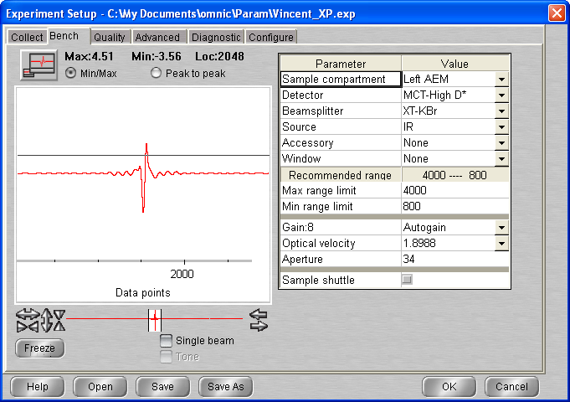

10 :26 T = 120K P = 1.10 * 10-9 mbar

|  |  |  |  |  |  |  |
| --- | --- | --- | --- | --- | --- | --- |
| **10 :30** | **_0042** | 120 | 120 | Isothermal 2 | 1.1 * 10 -9 | 4.62 |
| **11 :00** | **_0043** | 120 | 120 | Isothermal 3 | 1.1 * 10 -9 | 4.67 |
| **11 :15** | **_0044** | 120 | 120 | Isothermal 4 | 1.1 * 10 -9 | 4.67 |
| **11 :30** | **_0045** | 120 | 120 | Isothermal 4 | 1.1 * 10 -9 | 4.67 |
| **11 :45** | **_0046** | 120 | 120 | Isothermal 4 | 1.1 * 10 -9 | 4.67 |

## Annealing to 125 K

|  |  |  |  |  |  |  |
| --- | --- | --- | --- | --- | --- | --- |
| **12 :00** | **_0047** |  |  | Warm-up 1 |  |  |
| **12 :15** | **_0048** |  | 125.0 | Warm-up 2 |  | 4.66 |
| **12 :30** | **_0049** |  |  | Isothermal 1 |  |  |
| **12 :45** | **_0050** |  |  | Isothermal 2 |  | 4.66 |

## Annealing to 130 K

|  |  |  |  |  |  |  |
| --- | --- | --- | --- | --- | --- | --- |
| **13 :00** | **_0051** |  |  | Warm-up 1 |  | 4.66 |
| **13 :15** | **_0052** |  |  | Warm-up 2 |  |  |
| **13 :30** | **_0053** |  |  | Isothermal 1 |  | 4.65 |
| **13 :45** | **_0054** |  |  | Isothermal 2 |  | 4.65 |

## Annealing to 135 K

|  |  |  |  |  |  |  |  |
| --- | --- | --- | --- | --- | --- | --- | --- |
| **14 :00** | | **_0055** |  |  | Warm-up 1 |  |  |
| **14 :15** | | **_0056** |  |  | Warm-up 2 |  | 4.65 |
| **14 :30** | **_0057** |  |  | Isothermal 1 |  |  |
| **14 :45** | **_0058** |  |  | Isothermal 2 |  | 4.65 |

## Annealing to 140 K

|  |  |  |  |  |  |  |
| --- | --- | --- | --- | --- | --- | --- |
| **15 :00** | **_0059** |  |  | Warm-up 1 |  |  |
| **15 :15** | **_0060** |  |  | Warm-up 2 |  | 4.66 |
| **15 :30** | **_0061** |  |  | Isothermal 1 |  |  |
| **15 :45** | **_0062** |  |  | Isothermal 2 |  | 4.65 |

## Annealing to 145 K

|  |  |  |  |  |  |  |
| --- | --- | --- | --- | --- | --- | --- |
| **16 :00** | **_0063** |  |  | Warm-up 1 |  | 4.64 |
| **16 :15** | **_0064** |  |  | Warm-up 2 |  |  |
| **16 :30** | **_0065** |  |  | Isothermal 1 |  |  |
| **16 :45** | **_0066** |  |  | Isothermal 2 |  | 4.65 |

## Annealing to 150 K

|  |  |  |  |  |  |  |
| --- | --- | --- | --- | --- | --- | --- |
| **17 :00** | **_0067** |  |  | Warm-up 1 |  |  |
| **17 :15** | **_0068** |  |  | Warm-up 2 |  | 4.65 |
| **17 :30** | **_0069** |  |  | Isothermal 1 |  |  |
| **17 :45** | **_0070** |  |  | Isothermal 2 | 3.7 * 10-7 | 4.66 |

## Isotherm 150 K

|  |  |  |  |  |  |  |
| --- | --- | --- | --- | --- | --- | --- |
| **18 :00** | **_0071** |  |  | Isotherm 3 |  | 4.66 |
| **18 :15** | **_0072** |  |  | Isotherm 4 | 3.5 * 10-7 | 4.66 |
| **18 :30** | **_0073** |  |  | Isotherm 5 | 3.4 * 10-7 | 4.65 |
| **18 :45** | **_0074** |  |  | Isotherm 6 | 3.3 * 10-7 | 4.66 |

## Annealing to 155 K

|  |  |  |  |  |  |  |
| --- | --- | --- | --- | --- | --- | --- |
| **19 :00** | **_0075** |  |  | Warm-up 1 |  |  |
| **19 :15** | **_0076** |  |  | Warm-up 2 |  | 4.63 |
| **19 :30** | **_0077** |  |  | Warm-up 2 | 7.5 * 10-7 | 4.61 |
| **19 :40** | **_0078** |  |  | Warm-up 2 | 6.8 – 4.3 * 10-7 | 4.58 |

## Annealing to 160 K

|  |  |  |  |  |  |  |
| --- | --- | --- | --- | --- | --- | --- |
| **20 :00** | **_0079** |  |  | Warm-up 1 |  | 4.59 |
| **20 :15** | **_0080** |  |  | Warm-up 2 |  | 4.58 |

# Monday 12th Oct 2020 (VD)

9:10 T = 278.4 P = 2.7 * 10-9

9:18 Cryo turned on

11:05 Laser On

11:27 MCT Detector cooled

11:52 T= 21.5 P = 5 * 10-10 mbar

Wrong manipulation while aligning MCT detector … Had to be realigned (box opened …)

🡪 No sample produced

# Wednesday 14th Oct 2020 (VD)

10:02 T = 278.6 P = 2.6 * 10-9

10:02 Cryo turned on

10:02 Laser On

10:16 MCT Detector cooled

11:21 T= 21.7 K P = 5 * 10-10 mbar

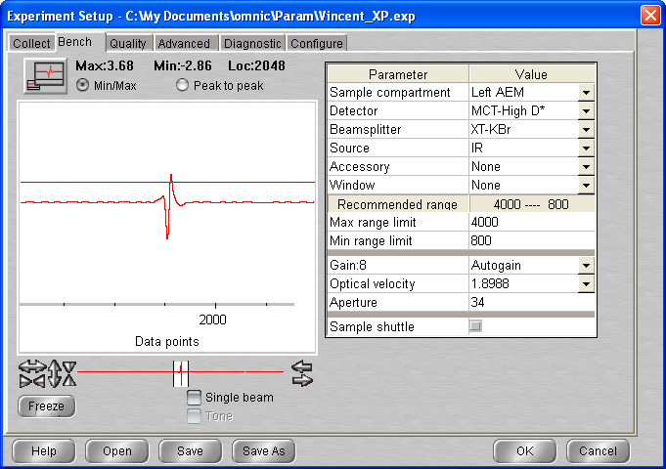

## Background scan(s) #1

**11:35 BG20201014_01**

512 scans res = 1 cm-1 signal = 3.69  
p = 5 10-10 mbar T = 21.5 K

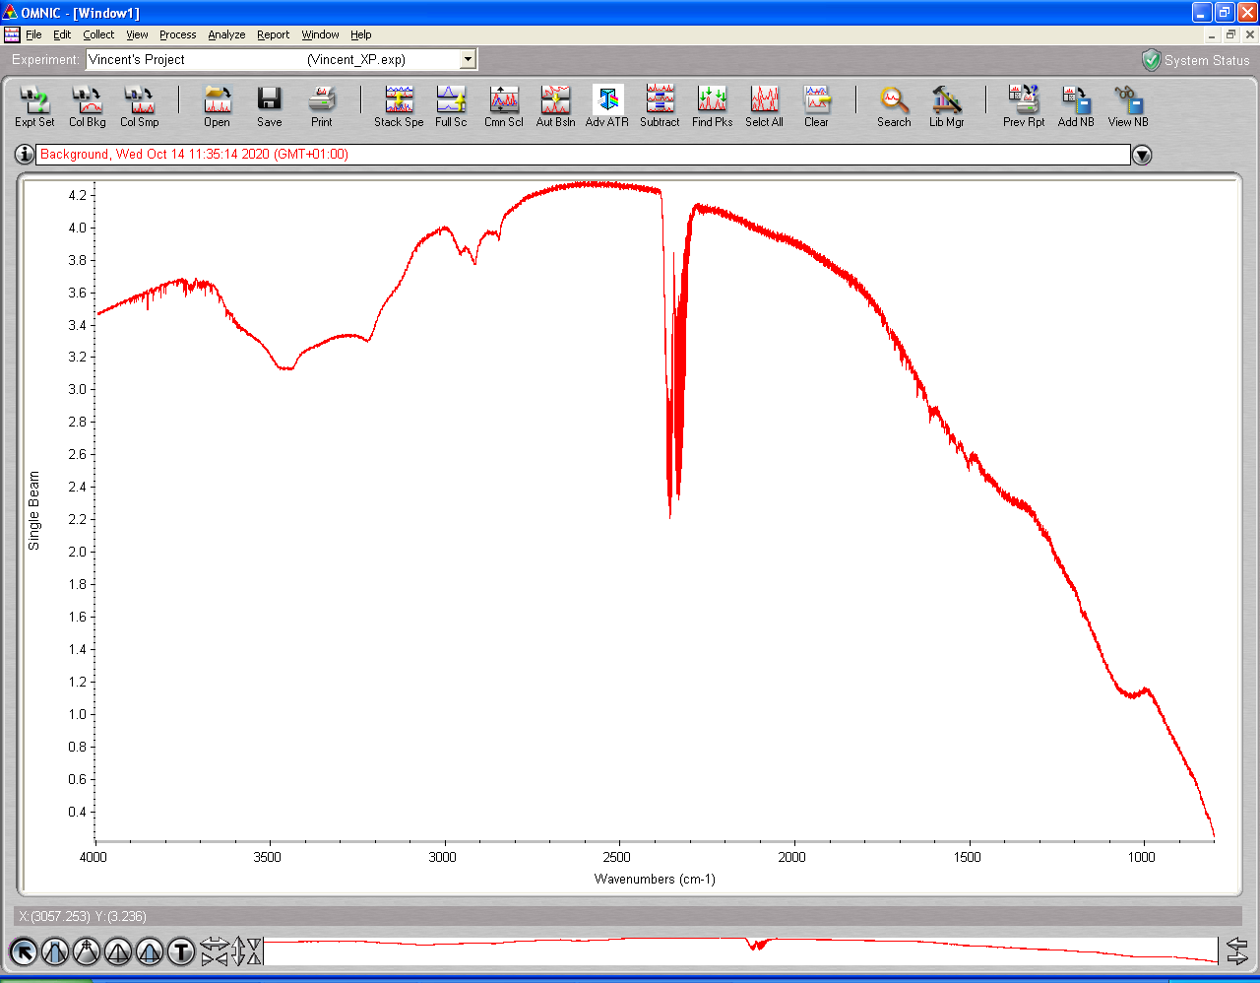

11:51 Heater setup to 120K

**11:35 BG20201014_02**

512 scans res = 1 cm-1 signal = 3.72  
p = 7 10-9 mbar T = 119.7 K

## Deposition #7: H2O @ 120K

11:40 20 min @ 1x10-7 mbar H2O

- Initial Temperature: 120 K

- Initial pressure: * 2.9-9 mbar

- Initial gas cell pressure: 7.51 Torr

- Deposition pressure: 1.01-1.09 * 10-7 mbar

- Laser signal: 78 mV

- Deposition time: 20 min

- pressure after deposition: 8 * 10-9 mbar

- final gas cell pressure = 0.684 Torr

12:56 Laser turned off

12:58 Head rotated

12:58 T = 120K P = 5.15 * 10-9 mbar

**12:58 ASW_2020_09_28_0001**

512 scans 1 cm-1 res signal 3.82  
p = 4.9 x 10-9 mbar T = 120 K

**13:27 ASW_2020_09_28_0002**

512 scans 1 cm-1 res signal 3.80  
p = 2.2 x 10-9 mbar T = 120 K

## Annealing to 125 K

|  |  |  |  |  |  |  |
| --- | --- | --- | --- | --- | --- | --- |
| **14 :00** | **_0003** | 120 |  | Warm-up 1 |  |  |
| **14 :15** | **_0004** |  |  | Warm-up 2 |  |  |
| **14 :30** | **_0005** |  |  | Isothermal 1 |  | 3.79 |

## Annealing to 130 K

|  |  |  |  |  |  |  |
| --- | --- | --- | --- | --- | --- | --- |
| **14 :45** | **_0006** | 125 |  | Warm-up 1 |  |  |
| **15:00** | **_0007** |  |  | Warm-up 2 |  | 3.79 |
| **15 :15** | **_0008** |  |  | Isothermal 1 |  | 3.78 |

## Annealing to 135 K

|  |  |  |  |  |  |  |
| --- | --- | --- | --- | --- | --- | --- |
| **15 :30** | **_0009** | 130 |  | Warm-up 1 |  |  |
| **15 :45** | **_0010** |  |  | Warm-up 2 |  | 3.78 |
| **16 : 00** | **_0011** |  |  | Isothermal 1 |  | 3.77 |

## Annealing to 140 K

|  |  |  |  |  |  |  |
| --- | --- | --- | --- | --- | --- | --- |
| **16 :15** | **_0012** | 135 |  | Warm-up 1 |  | 3.77 |
| **16 :30** | **_0013** |  |  | Warm-up 2 |  |  |
| **16 : 45** | **_0014** |  |  | Isothermal 1 |  | 3.76 |

## Annealing to 145 K

|  |  |  |  |  |  |  |
| --- | --- | --- | --- | --- | --- | --- |
| **17:00** | **_0015** | 140 |  | Warm-up 1 |  | 3.77 |
| **17 :15** | **_0016** |  |  | Warm-up 2 |  | 3.76 |
| **17 : 30** | **_0017** |  |  | Isothermal 1 |  |  |

## Annealing to 150 K

|  |  |  |  |  |  |  |
| --- | --- | --- | --- | --- | --- | --- |
| **17:45** | **_0018** | 145 |  | Warm-up 1 |  | 3.76 |
| **18 :00** | **_0019** |  |  | Warm-up 2 |  |  |
| **18 : 15** | **_0020** |  |  | Isothermal 1 |  | 3.73 |
| **18 : 30** | **_0021** |  |  | Isothermal 2 |  | 3.74 |

## Annealing to 160 K

|  |  |  |  |  |  |  |
| --- | --- | --- | --- | --- | --- | --- |
| **18 :45** | **_0022** | 145 |  | Warm-up 1 |  | 3.72 |
| **19 :00** | **_0023** |  |  | Warm-up 2 |  | 3.67 |

# Thursday 15th Oct 2020 (VD)

09:30 T = 277 P = 4.2 * 10-9

09:30 Cryo turned on

09:31 Laser On

10:02 T= 186.7 K P = 2.3 * 10-9 mbar

10:18 MCT Detector cooled

11:21 T= 21.7 K P = 5 * 10-10 mbar

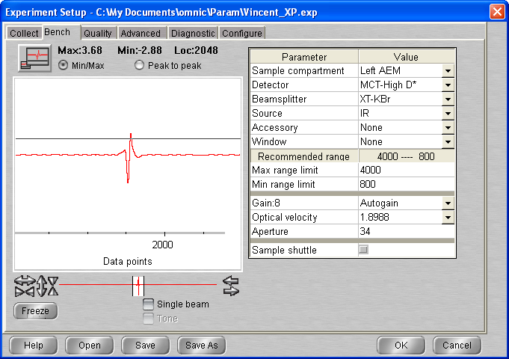

## Background scan(s) #1

**11:35 BG20201015_01**

512 scans res = 1 cm-1 signal = 3.68  
p = 8.3 10-10 mbar T = 21.2 K

11:46 T setup at 80K

12:11 T = 80K P = 1.9 10-9

**11:35 BG20201015_02**

512 scans res = 1 cm-1 signal = 3.68  
p = 1.8 10-9 mbar T = 80.0 K

## Deposition #8: H2O @ 80K

11:40 20 min @ 1x10-7 mbar H2O

- Initial Temperature: 80 K

- Initial pressure: 1.4 * 10-9 mbar

- Initial gas cell pressure: 7.666 Torr

- Deposition pressure: * 10-7 mbar

- Laser signal: 75 mV

- Deposition time: 20 min

- pressure after deposition: 1.1* 10-8 mbar

- final gas cell pressure = 0.657 Torr

13:27 Laser turned off

13:29 Head rotated

13:29 T = 80.1K P = 7 * 10-9 mbar

**13:29 ASW_2020_10_15_0001**

512 scans 1 cm-1 res signal 3.75  
p = 7 x 10-9 mbar T = 80.1 K

**14:19 ASW_2020_10_15_0002**

512 scans 1 cm-1 res signal 3.74  
p = 2.1 x 10-9 mbar T = 80.0 K

## Annealing to 90 K

|  |  |  |  |  |  |  |
| --- | --- | --- | --- | --- | --- | --- |
| **15 :00** | **_0003** | 80 |  | Warm-up 1 |  |  |
| **15 :15** | **_0004** |  |  | Warm-up 2 |  | 3.73 |
| **15 :30** | **_0005** |  |  | Isothermal 1 |  | 3.73 |

## Annealing to 100 K

|  |  |  |  |  |  |  |
| --- | --- | --- | --- | --- | --- | --- |
| **15 :45** | **_0006** | 90 |  | Warm-up 1 |  |  |
| **16 :00** | **_0007** |  |  | Warm-up 2 |  |  |
| **16 :15** | **_0008** |  |  | Isothermal 1 |  | 3.72 |

## Annealing to 110 K

|  |  |  |  |  |  |  |
| --- | --- | --- | --- | --- | --- | --- |
| **16 :30** | **_0009** | 100 |  | Warm-up 1 |  | 3.72 |
| **16 :45** | **_0010** |  |  | Warm-up 2 |  |  |
| **17 :00** | **_0011** |  |  | Isothermal 1 |  | 3.73 |

## Annealing to 120 K

|  |  |  |  |  |  |  |
| --- | --- | --- | --- | --- | --- | --- |
| **17 :15** | **_0012** | 110 |  | Warm-up 1 |  |  |
| **17 :30** | **_0013** |  |  | Warm-up 2 |  | 3.73 |
| **17 :45** | **_0014** |  |  | Isothermal 1 |  |  |

## Annealing to 125 K

|  |  |  |  |  |  |  |
| --- | --- | --- | --- | --- | --- | --- |
| **18 :00** | **_0015** | 120 |  | Warm-up 1 |  | 3.71 |
| **18 :15** | **_0016** |  |  | Warm-up 2 |  |  |
| **18 :30** | **_0017** |  |  | Isothermal 1 |  | 3.71 |

## Annealing to 130K

|  |  |  |  |  |  |  |
| --- | --- | --- | --- | --- | --- | --- |
| **18 :45** | **_0018** | 125 |  | Warm-up 1 |  |  |
| **19 :00** | **_0019** |  |  | Warm-up 2 |  | 3.71 |
| **19 :15** | **_0020** |  |  | Isothermal 1 |  | 3.71 |

## Annealing to 135K

|  |  |  |  |  |  |  |
| --- | --- | --- | --- | --- | --- | --- |
| **19 :30** | **_0021** | 130 |  | Warm-up 1 |  |  |
| **19 :45** | **_0022** |  |  | Warm-up 2 |  | 3.71 |
| **20 :00** | **_0023** |  |  | Isothermal 1 |  | 3.70 |

## Annealing to 140K

|  |  |  |  |  |  |  |
| --- | --- | --- | --- | --- | --- | --- |
| **20 :15** | **_0024** | 135 |  | Warm-up 1 |  | 3.70 |
| **20 :30** | **_0025** |  |  | Warm-up 2 |  | 3.69 |
| **20:45** | **_0026** |  |  | Isothermal 1 |  | 3.69 |

## Annealing to 145K

|  |  |  |  |  |  |  |
| --- | --- | --- | --- | --- | --- | --- |
| **21 :00** | **_0027** | 140 |  | Warm-up 1 |  |  |
| **21 :15** | **_0028** |  |  | Warm-up 2 |  | 3.70 |
| **21:30** | **_0029** |  |  | Isothermal 1 |  | 3.70 |

## Annealing to 150K

|  |  |  |  |  |  |  |
| --- | --- | --- | --- | --- | --- | --- |
| **21 :45** | **_0030** | 145 |  | Warm-up 1 |  | 3.69 |
| **22 : 00** | **_0031** |  |  | Warm-up 2 |  | 3.69 |
| **22:15** | **_0032** |  |  | Isothermal 1 | 4.1 * 10-7 | 3.68 |
| **22:30** | **_0033** |  |  | Isothermal 2 | 4 * 10-7 | 3.68 |

## Annealing to 160K

|  |  |  |  |  |  |  |
| --- | --- | --- | --- | --- | --- | --- |
| **22 :45** | **_0034** | 140 |  | Warm-up 1 |  |  |
| **23 :00** | **_0035** |  |  | Warm-up 2 |  | 3.66 |

# Thursday 22th Oct 2020 (VD)

10:50 T = 278.4 P = 2.2 * 10-9

10:51 Cryo turned on

10:51 Laser On

11:04 T= 241.6 K P = 1.7 * 10-9 mbar

11:59 MCT Detector cooled

12:00 T= 67.5 K P = 8 * 10-10 mbar

16;16 T = 21.2 K P = 5 * 10-10 mbar

# Background scan(s) #1

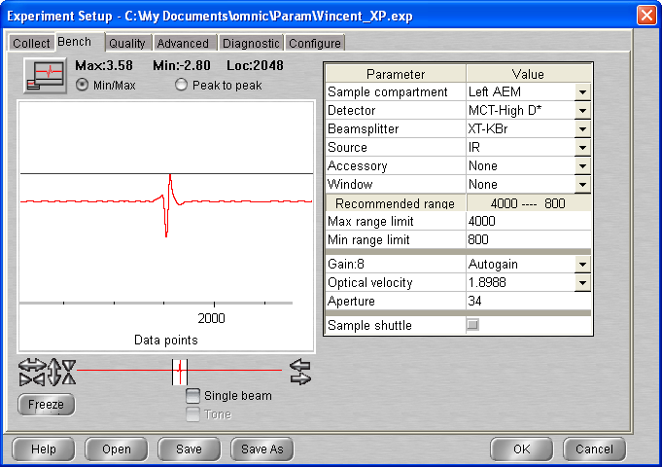

**16:25 BG20201022_01**

512 scans res = 1 cm-1 signal = 3.60  
p = 5 10-10 mbar T = 21.2 K

## Deposition #9: H2O @ 20K

17:40 20 min @ 1x10-7 mbar H2O

- Initial Temperature: 21.3 K

- Initial pressure: 5 * 10-10 mbar

- Initial gas cell pressure: 7.49 Torr

- Deposition pressure: * 10-7 mbar

- Laser signal: 59.3 mV

- Deposition time: 20 min

- pressure after deposition: 6.9 * 10-9 mbar

- final gas cell pressure = 6.28 Torr

18:04 Laser turned off

18:06 Head rotated

18:06 T = 21.3K P = 5.6 * 10-9 mbar

**18:08 ASW_2020_10_15_0001**

512 scans 1 cm-1 res signal 3.28  
p = 5 x 10-9 mbar T = 21.3 K

**18:30 ASW_2020_10_15_0002**

512 scans 1 cm-1 res signal 3.61  
p = 1.6 x 10-9 mbar T = 21.3 K

## Annealing to 120 K

|  |  |  |  |  |  |  |
| --- | --- | --- | --- | --- | --- | --- |
| **19 :00** | **_0003** | 21.2 |  | Warm-up 1 |  | 3.62 |
| **19 :15** | **_0004** |  |  | Warm-up 2 |  | 3.62 |
| **19 :30** | **_0005** |  |  | Isothermal 1 |  | 3.61 |

## Annealing to 130 K

|  |  |  |  |  |  |  |
| --- | --- | --- | --- | --- | --- | --- |
| **19 :45** | **_0006** | 120 |  | Warm-up 1 |  |  |
| **20 :00** | **_0007** |  |  | Warm-up 2 |  | 3.61 |
| **20:15** | **_0008** |  |  | Isothermal 1 |  | 3.60 |

## Scan 9 – 28 = Isothermal at 130K (MACRO)

Scan 29 🡪 09:19 (23-10) : Dummy scan to see 🡪 Nothing

09:53 MCT Detector cooled

**10:00 ASW_2020_10_15_0030**

512 scans 1 cm-1 res signal 3.63  
p = 3.7 x 10-9 mbar T = 129.9 K (Background 01)

## Scan 31 – 34 = Isothermal at 130K (MACRO)

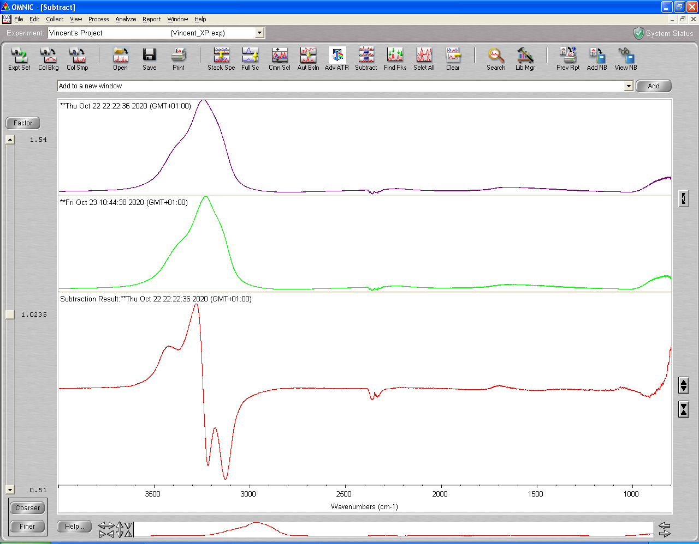

**12:45 ASW_2020_10_15_0035**

512 scans 1 cm-1 res signal 3.58  
p = 3.6 x 10-9 mbar T = 130 K (Background 01)

## Annealing to 132K

|  |  |  |  |  |  |  |
| --- | --- | --- | --- | --- | --- | --- |
| **13 :00** | **_0036** | 130 |  | Warm-up 1 |  | 3.70 |
| **13 : 15** | **_0037** |  |  | Warm-up 2 |  |  |
| **13:30** | **_0038** |  |  | Isothermal 1 |  | 3.69 |

## Annealing to 134K

|  |  |  |  |  |  |  |
| --- | --- | --- | --- | --- | --- | --- |
| **13 :45** | **_0039** | 132 |  | Warm-up 1 |  |  |
| **14 : 00** | **_0040** |  |  | Warm-up 2 |  | 3.69 |
| **14:15** | **_0041** |  |  | Isothermal 1 |  |  |

## Annealing to 136K

|  |  |  |  |  |  |  |
| --- | --- | --- | --- | --- | --- | --- |
| **14 :30** | **_0042** |  |  | Warm-up 1 |  |  |
| **14 : 45** | **_0043** |  |  | Warm-up 2 |  | 3.67 |
| **15:00** | **_0044** |  |  | Isothermal 1 |  |  |

## Annealing to 138K

|  |  |  |  |  |  |  |
| --- | --- | --- | --- | --- | --- | --- |
| **15 :15** | **_0045** |  |  | Warm-up 1 |  |  |
| **15 :30** | **_0046** |  |  | Warm-up 2 |  | 3.67 |
| **15:45** | **_0047** |  |  | Isothermal 1 |  | 3.67 |

## Annealing to 140K

|  |  |  |  |  |  |  |
| --- | --- | --- | --- | --- | --- | --- |
| **16 :00** | **_0048** |  |  | Warm-up 1 |  |  |
| **16 :15** | **_0049** |  |  | Warm-up 2 |  | 3.67 |
| **16:30** | **_0050** |  |  | Isothermal 1 |  | 3.67 |

## Annealing to 142K

|  |  |  |  |  |  |  |
| --- | --- | --- | --- | --- | --- | --- |
| **16 :45** | **_0051** |  |  | Warm-up 1 |  | 3.66 |
| **17 :00** | **_0052** |  |  | Warm-up 2 |  | 3.66 |
| **17:15** | **_0053** |  |  | Isothermal 1 |  | 3.66 |

## Annealing to 145K

|  |  |  |  |  |  |  |
| --- | --- | --- | --- | --- | --- | --- |
| **17 :30** | **_0054** |  |  | Warm-up 1 |  |  |
| **17 :45** | **_0055** |  |  | Warm-up 2 |  | 3.67 |
| **18:00** | **_0056** |  |  | Isothermal 1 |  |  |

21:00 ASW_2020_10_15_0057 🡪 150K 512 scans 1 cm-1 res

## Scan 58 – 67 = Isothermal at 150K (MACRO)

**21:00 ASW_2020_10_15_0068 🡪 160K**

512 scans 1 cm-1 res signal 3.64

# Friday 30th Oct 2020 (VD)

11:00 T = 278.4 P = 1.9 * 10-9

11:01 Cryo turned on

11:01 Laser On

11:09 T= 253.7 K P = 1.7 * 10-9 mbar

11:20 MCT Detector cooled

12:07 T = 74.5 P = 8.2* 10 -10

12:37 T = 21.3 P = 5 * 10-10

12:38 T set up at 130K

13:02 T = 129.8 P = 8.9 10e-9

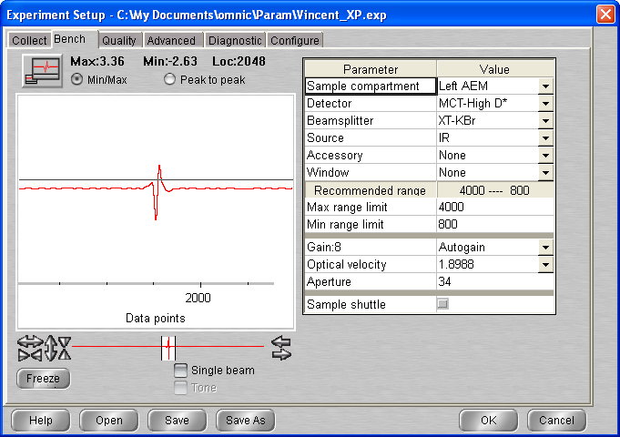

# Background scan(s) #1

**16:25 BG20201030_01**

512 scans res = 1 cm-1 signal = 3.43  
p = 6.7 10-10 mbar T = 130 K

## Deposition #10: H2O @ 130K

13:47 20 min @ 1x10-7 mbar H2O

- Initial Temperature: 130 K

- Initial pressure: 3.1 * 10-9 mbar

- Initial gas cell pressure: 7.52 Torr

- Deposition pressure: * 10-7 mbar

- Laser signal: 57.8 mV

- Deposition time: 20 min

- pressure after deposition: 2.7 * 10-8 mbar

- final gas cell pressure = 6.65 Torr

14:09 Laser turned off

14:10 Head rotated

14:10 T = 130K P = 3.2 * 10-8 mbar

**14:25 ASW_2020_10_30_0001**

512 scans 1 cm-1 res signal 3.66  
p = 2.9 x 10-8 mbar T = 130K

Scan 2 – 11 Macro

17 : 20 🡪 Scan 12 – 31 Macro

## Saturday 31/10

15 : 13 T = 130 P = 1 * 10-8

15 :37 MCT Detector cooled

**16:00 ASW_2020_10_30_0032**

512 scans 1 cm-1 res signal 3.48  
p = 9.9 x 10-9 mbar T = 130K

16 : 15 🡪 Scan 33 – 52 Macro

21 : 10 🡪 Scan 53 – 72 Macro

## Monday 02/1

11 : 05 T = 130 P = 4.9 * 10-9

11 :06 MCT Detector cooled

**11:36 ASW_2020_10_30_0073**

512 scans 1 cm-1 res signal 2.84  
p = 4.9 x 10-9 mbar T = 130K

🡪 Scan 74 – 93 Macro 130 K (end at 16:47)

## Ramp to 135 K

**17:00 ASW_2020_10_30_0094**

512 scans 1 cm-1 res signal 2.94  
p = 4.8 x 10-9 mbar T = 130K

17 :15 🡪 Scan 95 – 114 Macro 135 K

03/11 🡪 10:49 MCT Detector cooled

**11:42 ASW_2020_10_30_0115**

512 scans 1 cm-1 res signal 2.85  
p = 1.1 x 10-8 mbar T = 130K

## Ramp to 140 K

**13:00 ASW_2020_10_30_0116**

512 scans 1 cm-1 res signal 2.99  
p = 1.1 x 10-8 mbar T = 135K

**13:15 ASW_2020_10_30_0117**

512 scans 1 cm-1 res signal 2.99  
p = 3.4 x 10-8 mbar T = 140K

**13:30 ASW_2020_10_30_0118**

512 scans 1 cm-1 res signal 2.99  
p = 3.5 x 10-8 mbar T = 140K

## Ramp to 145 K

**13:45 ASW_2020_10_30_0119**

512 scans 1 cm-1 res signal 2.99  
p = 3.5 x 10-8 mbar T = 140K

**14:00 ASW_2020_10_30_0120**

512 scans 1 cm-1 res signal 2.98 T = 145K

**14:15 ASW_2020_10_30_0121**

512 scans 1 cm-1 res signal 2.96  
p = 1.2 x 10-7 mbar T = 145K

## Ramp to 150 K

**14:30 ASW_2020_10_30_0119**

512 scans 1 cm-1 res signal 2.99  
p = 3.5 x 10-8 mbar T = 140K

# 04/11 –

10 :47 MCT detector cooled

**11:20 ASW_2020_10_30_0143**

512 scans 1 cm-1 res signal 2.30  
p = 6.5 x 10-8 mbar T = 150K

# Monday 16th Nov 2020 (VD)

10:20 T = 278.4 P = 1.9 * 10-9

10:21 Cryo turned on

11:41 Laser On

11:59 MCT Detector cooled

11:59 T = 21.2 P = 5.2* 10 -10

12:19 T= 21.1 P= 5.2 10-10

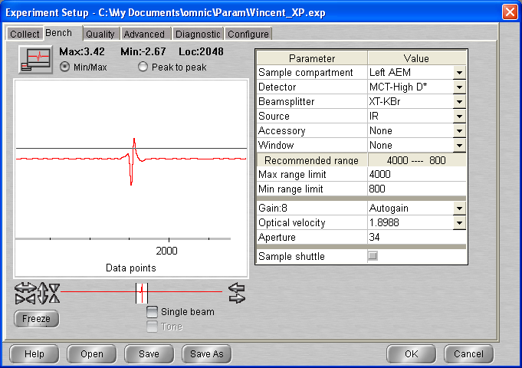

# Background scan(s) #1

**12:25 BG20201116_01**

512 scans res = 1 cm-1 signal = 3.42  
p = 5.3 10-10 mbar T = 21.1 K

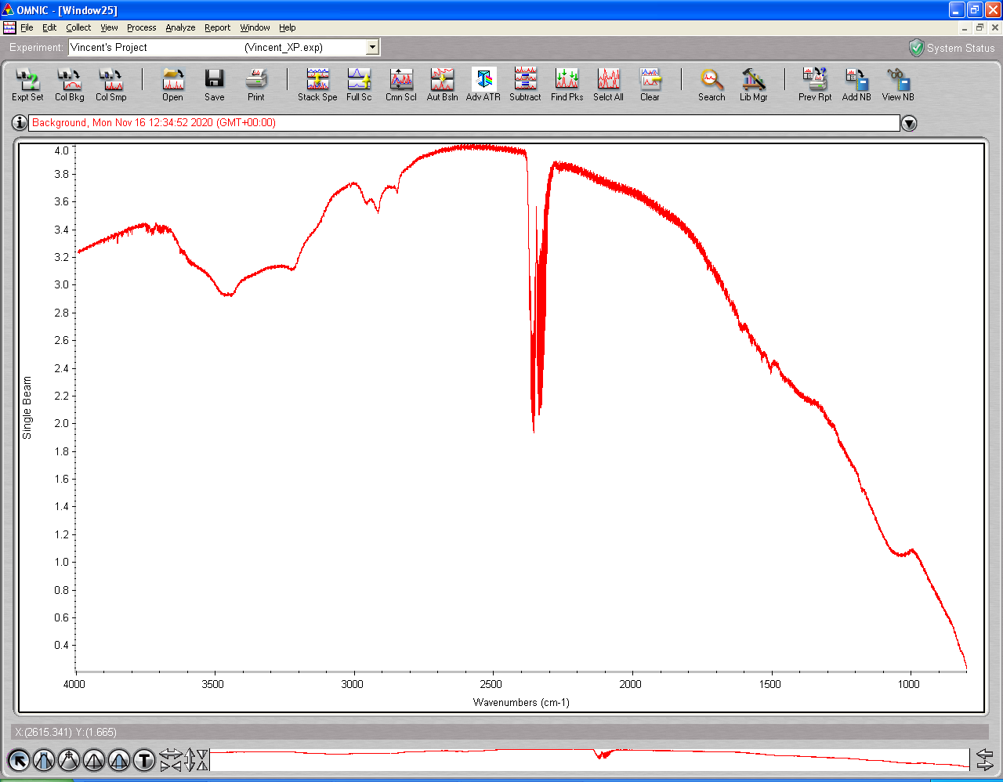

## Deposition #11: H2O @ 20K

13:47 20 min @ 1x10-7 mbar H2O

- Initial Temperature: 21.1 K

- Initial pressure: 5.7 * 10-10 mbar

- Initial gas cell pressure: 7.72 Torr

- Deposition pressure: * 10-7 mbar

- Laser signal: 227.6 mV

- Deposition time: 20 min

- pressure after deposition: 1.4 * 10-8 mbar

- final gas cell pressure = 6.46 Torr

14:40 Laser turned off

14:42 Head rotated

14:42 T= 21.1K P= 8.4 10-9

**14:43 ASW_2020_11_16_0001**

512 scans 1 cm-1 res signal 3.04  
p = 6.7 x 10-9 mbar T = 21.1K

**15:01 ASW_2020_11_16_0002**

512 scans 1 cm-1 res signal 3.43  
p = 2.6 x 10-9 mbar T = 21.1K

## Annealing to 60K

**15:25 ASW_2020_11_16_0003**

512 scans 1 cm-1 res signal 3.43  
p = 1.8 x 10-9 mbar T = 21.1K

15 :40 Scan 4 – 12 = MACRO isotherm at 60 – MACRO FAILED !!!!

**16:21 ASW_2020_11_16_0004**

512 scans 1 cm-1 res signal 3.41  
p = 2.3 x 10-9 mbar T = 60.0K

**16:35 ASW_2020_11_16_0005**

512 scans 1 cm-1 res signal 3.41  
p = 2.1 x 10-9 mbar T = 60.0K

## Annealing to 70K

**17:00 ASW_2020_11_16_0006**

512 scans 1 cm-1 res signal 3.40  
p = 1.9 x 10-9 mbar T = 60k

**17:15 ASW_2020_11_16_0007**

512 scans 1 cm-1 res signal 3.40  
p = 4.5 x 10-9 mbar T = 70k

17 :30 Scan 8 – 18 = MACRO isotherm at 70

20:04 Macro finished

## Annealing to 130K

**20:10 ASW_2020_11_16_00019**

512 scans 1 cm-1 res signal 3.40  
p = 1.3 x 10-9 mbar T = 70k

20 :25 Scan 20 – 40 = MACRO isotherm at 130

## 17/11

11:25 MCT Detector cooled

**12:05 ASW_2020_11_16_00040**

512 scans 1 cm-1 res signal 3.29  
p = 4.8 x 10-9 mbar T = 130k

**12:52 ASW_2020_11_16_00041**

512 scans 1 cm-1 res signal 3.51  
p = 4.8 x 10-9 mbar T = 130k

**13:22 ASW_2020_11_16_00042**

512 scans 1 cm-1 res signal 3.51  
p = 4.8 x 10-9 mbar T = 130k

## Annealing to 136K

**15:00 ASW_2020_11_16_0043**

512 scans 1 cm-1 res signal   
p = 4.8 x 10-9 mbar T = 130k

**15:15 ASW_2020_11_16_0044**

512 scans 1 cm-1 res signal = 3.46  
p = 2.1 x 10-8 mbar T = 136k

**15:30 ASW_2020_11_16_0045**

512 scans 1 cm-1 res signal = 3.46  
p = 2.2 x 10-8 mbar T = 136k

**15:45 ASW_2020_11_16_0046**

512 scans 1 cm-1 res signal = 3.46  
p = 2.2 x 10-8 mbar T = 136k

## Annealing to 137K

**16:00 ASW_2020_11_16_0047**

512 scans 1 cm-1 res signal   
p = 2.4 x 10-8 mbar T = 136k

**16:15 ASW_2020_11_16_0048**

512 scans 1 cm-1 res signal

**16:30 ASW_2020_11_16_0049**

512 scans 1 cm-1 res signal

**16:45 ASW_2020_11_16_0050**

512 scans 1 cm-1 res signal

## Annealing to 138K

**17:00 ASW_2020_11_16_0051**

512 scans 1 cm-1 res signal

**17:15 ASW_2020_11_16_0052**

512 scans 1 cm-1 res signal

**17:30 ASW_2020_11_16_0053**

512 scans 1 cm-1 res signal

**17:45 ASW_2020_11_16_0054**

512 scans 1 cm-1 res signal

18 : 00 Scan 55 – 64 = MACRO isotherm at 138

20:22 – MACRO Finished T = 133.7 (on Manual) … Don`t know what happened

## Annealing to 140K

**20:25 ASW_2020_11_16_0065**

512 scans 1 cm-1 res signal

**20:45 ASW_2020_11_16_0066**

512 scans 1 cm-1 res signal

**21:05 ASW_2020_11_16_0067**

512 scans 1 cm-1 res signal 3.46

## Annealing to 145K

**21:25 ASW_2020_11_16_0068**

512 scans 1 cm-1 res signal 3.44

21:40 Macro 20 scans

## 18/11

11:06 T = 144.8 P = 8.0 * 10-8

11:17 MCT Detector cooled

**11:30 ASW_2020_11_16_0089**

512 scans 1 cm-1 res signal 3.25

11:46 Heater turned off / Compressor turned off

# Thursday 19th Nov 2020 (VD)

10:16 T = 278.3 P = 3.1 * 10-9

10:17 Cryo turned on

10:43 Laser On

10:49 MCT Detector cooled

11:59 T = 21.2 P = 5.2* 10 -10

17:03 MCT Detector cooled again

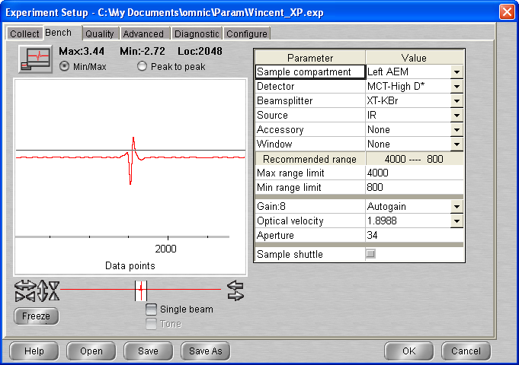

**17:34 BG20201119_01**

512 scans res = 1 cm-1 signal = 3.42  
p = 9.5 10-10 mbar T = 21.1 K

17 :53 Laser turned on (forgot to do it earlier)

## Deposition #11: H2O @ 20K

13:47 20 min @ 1x10-7 mbar H2O

- Initial Temperature: 21.1 K

- Initial pressure: 9.3 * 10-10 mbar

- Initial gas cell pressure: 7.72 Torr

- Deposition pressure: 1* 10-7 mbar

- Laser signal: 227.6 mV

- Deposition time: 21:30 min

- pressure after deposition: 1.4 * 10-8 mbar

- final gas cell pressure = 6.46 Torr

18:33 Laser turned off

18:34 Head rotated

18:34 T= 21.1K P= 9.5 10-9

**18:35 ASW_2020_11_19_0001**

512 scans 1 cm-1 res signal 3.40  
p = 8.2 x 10-9 mbar T = 21.1K

**18:xx ASW_2020_11_19_0002**

512 scans 1 cm-1 res signal 3.38  
p = 2.6 x 10-9 mbar T = 21.1K

## Annealing to 60K

**19:10 ASW_2020_11_19_0003**

512 scans 1 cm-1 res signal 3.37  
p = 2.4 x 10-9 mbar T = 21.1K

19 :30 Scan 4 – 10 = MACRO isotherm at 60

## Annealing to 70K

**21:05 ASW_2020_11_19_0011**

512 scans 1 cm-1 res signal 3.36

21 :20 MACRO 40 scans isotherm at 70 (up to 51)

## 20/11

13:16 T = 70 P = 1.0 * 10-9

13:17 MCT Detector cooled

**14:20 ASW_2020_11_19_0052**

512 scans 1 cm-1 res signal 3.25  
p = 1.0 x 10-9 mbar T = 70K

**14:45 ASW_2020_11_19_0053**

512 scans 1 cm-1 res signal 3.42  
p = 1.0 x 10-9 mbar T = 70K

## Annealing to 130K

**15:10 ASW_2020_11_16_00054**

512 scans 1 cm-1 res signal 3.42  
p = 1.1 x 10-9 mbar

15 :25 Scan 55 – 67 = MACRO isotherm at 130

## Annealing to 135K

18:30 **ASW_2020_11_16_00068**

512 scans 1 cm-1 res signal 3.39

18 :45 MACRO 20 isotherm at 135

21/11/20

16:30 MCT Detector cooled

P = 9.8 10e-9 T = 135K

17:10 **ASW_2020_11_16_00089**

512 scans 1 cm-1 res signal 3.32

## Annealing to 140K

17:30 **ASW_2020_11_16_00090**

512 scans 1 cm-1 res signal 3.50

P= 9.8 e-9 T= 135K

17:45 **ASW_2020_11_16_0091**

512 scans 1 cm-1 res signal 3.52

18:00 **ASW_2020_11_16_0092**

512 scans 1 cm-1 res signal 3.53

## Annealing to 145K

18:15 **ASW_2020_11_16_00093**

512 scans 1 cm-1 res signal 3.54

18 :30 MACRO 100 isotherm at 145 interrupted loop 77

21/11/20

12:21 MCT Detector cooled

P = 5.8 10e-8 T = 145.1 K

13:22 **ASW_2020_11_16_0160**

512 scans 1 cm-1 res signal 3.23

T = 145K P = 4.8 * 10-8

13 :38 Cryo turned off

Heater man 300K and switched off

# Thursday 23th Nov 2020 (VD)

9:57 T = 278.4 P = 3.6 * 10-9

9:58 T send to 300K (P rise to 10-7 )

10:03 P start to decrease 🡪 Heater set up to Man 0

10:05 Cryo turned on

10:05 Laser On

11:13 MCT Detector cooled

11:34 T = 21.2 K P= 3.6 * 10-9

11: 36 Heater setted up at 40K

12:19 T = 40.0K P = 3.2 * 10-9

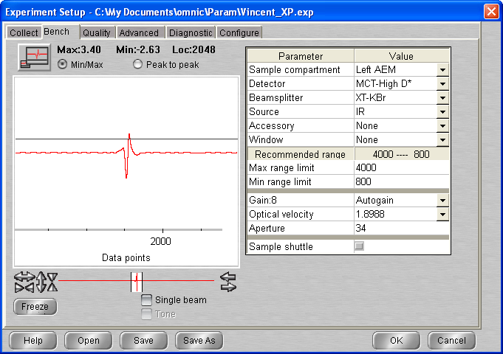

# Background scan(s) #1

**12:25 BG20201123_01**

512 scans res = 1 cm-1 signal = 3.59  
p = 3.2 10-9 mbar T = 40.1 K

## Deposition #12: H2O @ 40K

12:50 20 min @ 1x10-7 mbar H2O

- Initial Temperature: 40.0 K

- Initial pressure: 2.9 * 10-9 mbar

- Initial gas cell pressure: 7.54 Torr

- Deposition pressure: 1* 10-7 mbar

- Laser signal: 246.4 mV

- Deposition time: 20 min

- pressure after deposition: 1.3 * 10-8 mbar

- final gas cell pressure = 6.62 Torr

13:12 Laser turned off

13:15 Head rotated

**13:15 ASW_2020_11_23_0001**

512 scans 1 cm-1 res signal 3.82  
p = 9.6 x 10-9 mbar T = 40K

**13:46 ASW_2020_11_23_0002**

512 scans 1 cm-1 res signal 3.81  
p = 9.6 x 10-9 mbar T = 40K

## Annealing to 60K

**14:05 ASW_2020_11_23_0003**

512 scans 1 cm-1 res signal   
p = 3.0 x 10-9 mbar

14 :20 Scan 4 – 12 = MACRO isotherm at 60

## Annealing to 80K

**16:30 ASW_2020_11_23_0013**

512 scans 1 cm-1 res signal   
p = 2.2 x 10-9 mbar

16 :45 Scan 14 – 22 = MACRO isotherm at 80

## Annealing to 100K

**19:00 ASW_2020_11_23_0023**

512 scans 1 cm-1 res signal   
p = 2.2 x 10-9 mbar

19 :15 Scan 24 – 32 = MACRO isotherm at 100

## 24/11

09 :43 T = 100K P = 1.4 * 10e-9

10:00 MCT Detector cooled

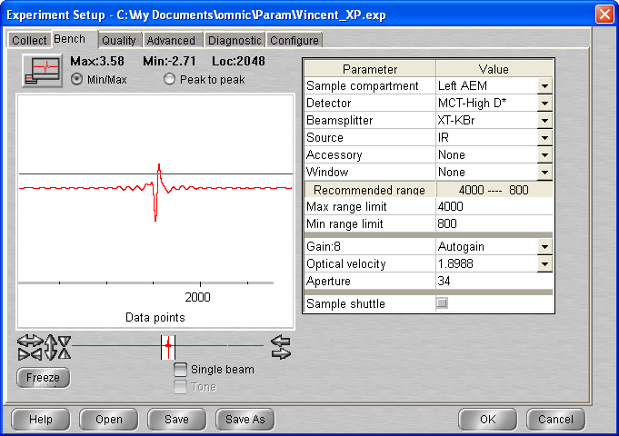

**10:16 ASW_2020_11_23_0033**

512 scans 1 cm-1 res signal 3.65  
p = 1.4 x 10-9 mbar T = 100K

**10:35 ASW_2020_11_23_0034**

512 scans 1 cm-1 res signal 3.65  
p = 1.4 x 10-9 mbar T = 100K

## Annealing to 120K

**11:00 ASW_2020_11_23_0035**

512 scans 1 cm-1 res signal   
p = 2.2 x 10-9 mbar

11 :15 Scan 36 – 44 = MACRO isotherm at 120

## Annealing to 130K

**11:00 ASW_2020_11_23_0045**

512 scans 1 cm-1 res signal   
p = 2.0 x 10-9 mbar

13 :40 Scan 46 – 54 = MACRO isotherm at 130

## Annealing to 135K

**15:50 ASW_2020_11_23_0055**

512 scans 1 cm-1 res signal   
p = 6.5 x 10-9 mbar

16 :05 Scan 56 – 64 = MACRO isotherm at 135

## Annealing to 140K

**18:15 ASW_2020_11_23_0065**

512 scans 1 cm-1 res signal 3.83

18 :30 Scan 66 – 74 = MACRO isotherm at 140

20:39 MCT Detector cooled

**20:41 ASW_2020_11_23_0075**

512 scans 1 cm-1 res signal 3.69

P = 3.8 * 10-8 T = 140.0

## Annealing to 145K

**21:00 ASW_2020_11_23_0076**

512 scans 1 cm-1 res signal 3.37

P= 3.4 10-8   
21 :15 MACRO isotherm at 145 80 scans

## 25/11

13:27 Loop exit at 69 scans 🡪 UP TO SCAN 144

P = 2.27 10e-8

13:34 MCT Detector cooled

13:35 Macro 20 scans (isotherm 145)

MACRO 20 scans

18:40 P = 8.5 * 10-9

**18:40 ASW_2020_11_23_0165**

512 scans 1 cm-1 res signal 3.78

18 :57 Cryo turned off, heater setted up at 300 (P rise to 3 * 10-7 🡪 ice wasn`t fully desorbed)

19:00 P = 4.5 e-7 T = 163.9

19:01 T = 174.4 P = 7.5 e-7

At 177 K P rise to 10-5 and then decrease

# Thursday 26th Nov 2020 (VD)

T = 277.9 P = 4.9 e-9

9:50 Cryo ON

13:56 MCT Detector cooled

14:00 Laser On

14:00 T set up 140K

# Background scan(s) #1

**12:25 BG20201126_01**

512 scans res = 1 cm-1 signal = 3.59

## Deposition #12: H2O @ 140K

15:30 20 min @ 1x10-7 mbar H2O

- Initial Temperature: 140.0 K

- Initial pressure: 7.5 * 10-9 mbar

- Initial gas cell pressure: 7.57 Torr

- Deposition pressure: 1* 10-7 mbar

- Laser signal: 237.3 mV

PROBLEM with leak valve … (very thick sample, very quick flow)

**15:27 ASW_2020_11_26_0001**

512 scans 1 cm-1 res signal 3.38

**15:43 ASW_2020_11_26_0002**

512 scans 1 cm-1 res signal 3.38

16 :00 Heater turned off and Macro 20 scans

20:40 Macro finished

## Annealing to 120K

**20:45 ASW_2020_11_26_0023**

512 scans 1 cm-1 res signal 3.34

P = 5 * 10-9 T = 20.7

**21:00 ASW_2020_11_26_0024**

512 scans 1 cm-1 res signal 3.34

P = 5.5 * 10-8 T = 119

**21:15 ASW_2020_11_26_0025**

512 scans 1 cm-1 res signal 3.34

## Annealing to 140K

**21:30 ASW_2020_11_26_0026**

512 scans 1 cm-1 res signal 3.34

**21:45 ASW_2020_11_26_0027**

512 scans 1 cm-1 res signal 3.34

**22:00 ASW_2020_11_26_0028**

512 scans 1 cm-1 res signal 3.34

22 :18 MCT Detector cooled

**22:20 ASW_2020_11_26_0029**

512 scans 1 cm-1 res signal 3.32

## Annealing to 145K

**22:37 ASW_2020_11_26_0030**

512 scans 1 cm-1 res signal 3.33

22:52 Macro 60 scans – EXIT AT LOOP 45 up to scan 75

## Annealing to 150K

**09:20 ASW_2020_11_26_0076**

512 scans 1 cm-1 res signal 3.33

**09:35 ASW_2020_11_26_0077**

512 scans 1 cm-1 res signal 3.32

**09:49 ASW_2020_11_26_0078**

512 scans 1 cm-1 res signal 3.32

## Annealing to 160K

**10:04 ASW_2020_11_26_0079**

512 scans 1 cm-1 res signal 3.33

**10:18 ASW_2020_11_26_0080**

512 scans 1 cm-1 res signal 3.33

**10:32 ASW_2020_11_26_0081**

512 scans 1 cm-1 res signal 3.32

10 :48 Cryo turned off

10 :50 Heater 300K

12 :45 P = 3.98 * 10-7

16 :26 P = 1.14 10-7

16 :26 Turbo off

## Friday 27th Nov 2020 (VD)

PAC was switched off last Friday afternoon – for power shut down over the weekend.

T = 277.9

13:35 Rotary on P = 4.96 x 10-3 mbar – switched on and pumped down within minutes

**NB – Turbo backing rotary pump has a problem with the on/off switch**

13:41 Turbo ON

13:45 1.4x10-6 mbar

13:50 P = 7x10-7 mbar

13:52 p=5.5x10-7 mbar

## Wednesday 2nd Dec 2020

14:50 T = 278.5 P = 6.4 10-9

Cry-cooling : 14:50 Cry turned on

15:03 T = 247.5 P = 5.8 * 10-9

15:29 T = 170.2 P = 4.7 e-9 mbar

16:00 T = 66.7 P = 3.4 e-9

16:10 T = 21.3 P = 9.3 * 10-10

16:10 Cryo - off

## Friday 3rd Dec 2020

**Ethane gas line installation**

09:58 T = 278.0K P = 5.7 * 10-9 mbar

## Thursday 21st Jan 2021

10:38 T = 278.5 P = 2.3 * 10-8

10:40 Cryo turned on

11:03 T = 210 K P= 2.05 * 10-8

11:38 T = 103 K P= 1.55 * 10-8

11:42 Laser On

11:57 T = 121.5 K P= 2.6 * 10-9

12:08 MCT Detector cooled

12:36 T = T setup to 60K

13:24 T = 60.0K P = 1.8 * 10-8

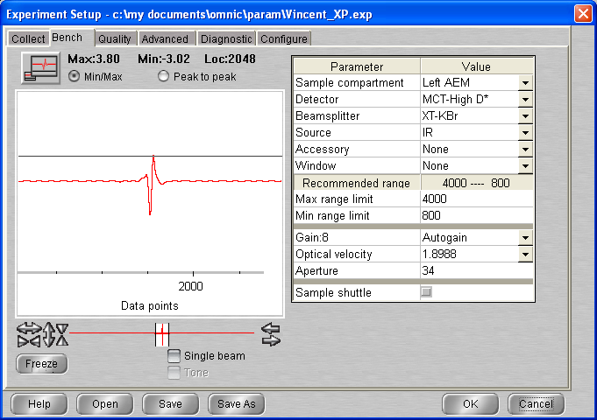

# Background scan(s) #1

**13:30 BG20210121_01**

512 scans res = 1 cm-1 signal = 3.80  
p = 1.8 10-8 mbar T = 60 K

Open gas cell valve (amont - bottom) -> P is now 4.9 * 10-9 (don`t know where it was before)

Cf below comparison between background this XP vs 11-16

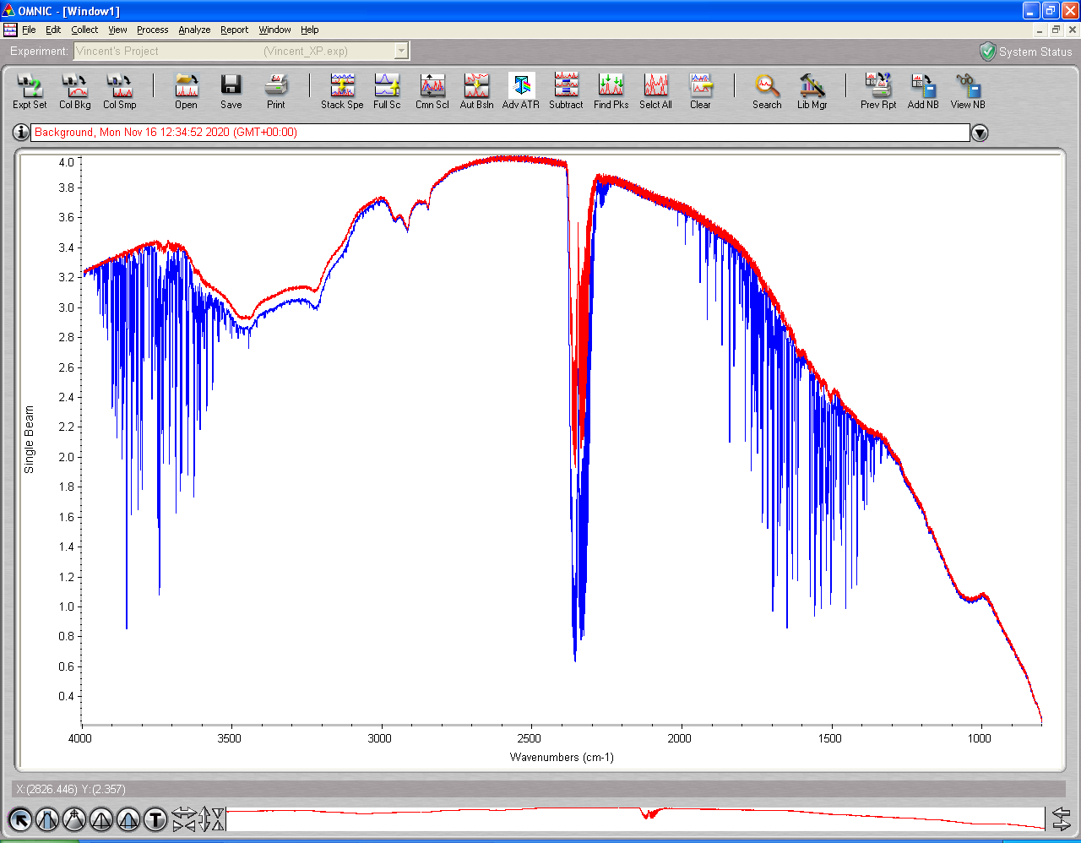

**13:44 BG20210121_02**

512 scans res = 1 cm-1 signal = 3.86  
p =  T = 60 K

## Deposition #14: H2O @ 60K

14:30 20 min @ 1x10-7 mbar H2O

- Initial Temperature: 60.0 K

- Initial pressure: 3.0 * 10-9 mbar

- Initial gas cell pressure: 7.17 Torr

(decrease slightly for some time ~ 10 min)

- Deposition pressure: 1* 10-7 mbar

- Laser signal: 250.1 mV

- Deposition time: 20 min

- pressure after deposition: 1.9 * 10-8 mbar

Open the leak rather than shutt it at the end (few extra material at end of deposition …)

- final gas cell pressure = 5.9 Torr

14:56 Laser turned off

14:58 Head rotated

**15:00 ASW_2020_11_23_0001 (bcg 01 used)**

512 scans 1 cm-1 res signal 4.18  
p = 9.3 x 10-9 mbar T = 60K

**15:15 ASW_2020_11_23_0002**

512 scans 1 cm-1 res signal 4.20  
p = 5.3 x 10-9 mbar T = 60K

ABORTED

# Monday 25th Nov 2020 (VD)

11:12 T = 278.7 P = 4.0 * 10-9

11:13 Cryo turned on

11:22 T = 255.2 P = 3.7 * 10-9

12:31 T = 21.1 P 1.5 * 10-9

12:56 Laser On

13:05 MCT Detector cooled

13:16 T = 20.8 P = 1.4* 10 -9

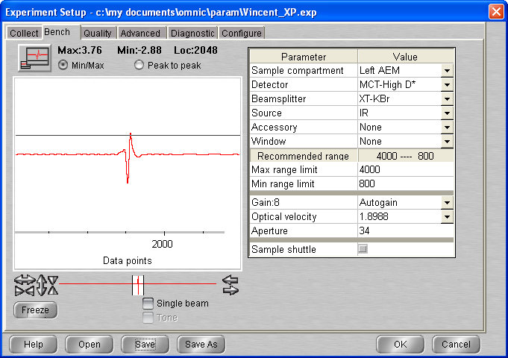

13:19 T setup to 60K (P rose up to 8 * 10-8)

13:32 T = 59.7 P = 1.7 e-9

# Background scan(s) #1

**13:55 BG20210125_01**

512 scans res = 1 cm-1 signal = 4.12  
p = 1.7 10-9 mbar T = 60 K

## Deposition #14: H2O @ 60K

14:20 20 min @ 1x10-7 mbar H2O

- Initial Temperature: 60.0 K

- Initial pressure: 1.6 * 10-9 mbar

- Initial gas cell pressure: 7.41 Torr

- Deposition pressure: 1 * 10-7 mbar

- Laser signal: 250.0 mV

- Deposition time: 20 min

- pressure after deposition: 1.6 * 10-8 mbar

Open the leak rather than shutt it at the end (few extra material at end of deposition …)

- final gas cell pressure = 6.37 Torr

14:40 Laser turned off

14:42 Head rotated

**14:44 ASW_2021_01_25_0001**

512 scans 1 cm-1 res signal 3.96  
p = 8.0 x 10-9 mbar T = 60K

**15:04 ASW_2021_01_25_0002**

512 scans 1 cm-1 res signal 3.96  
p = 3.4 x 10-9 mbar T = 60K

## Annealing to 80K

**15:30 ASW_2021_01_25_0003**

512 scans 1 cm-1 res signal 3.94  
p =

**15:45 ASW_2021_01_25_0004**

512 scans 1 cm-1 res signal 3.93  
p = 5.5 x 10-9 mbar

**16:00 ASW_2021_01_25_0005**

512 scans 1 cm-1 res signal 3.92  
p = 4 x 10-9 mbar

**16:15 ASW_2021_01_25_0006**

512 scans 1 cm-1 res signal 3.91  
p =

## Annealing to 100K

**16:30 ASW_2021_01_25_0007**

512 scans 1 cm-1 res signal 3.91  
p =

**16:45 ASW_2021_01_25_0008**

512 scans 1 cm-1 res signal 3.91  
p =

**17:00 ASW_2021_01_25_0009**

512 scans 1 cm-1 res signal 3.90  
p =

**17:15 ASW_2021_01_25_0010**

512 scans 1 cm-1 res signal 3.90  
p =

17:30 macro 20 scan

## 26/01

09 :32 T = 100K P = 1.7 * 10e-9

09:43 MCT Detector cooled

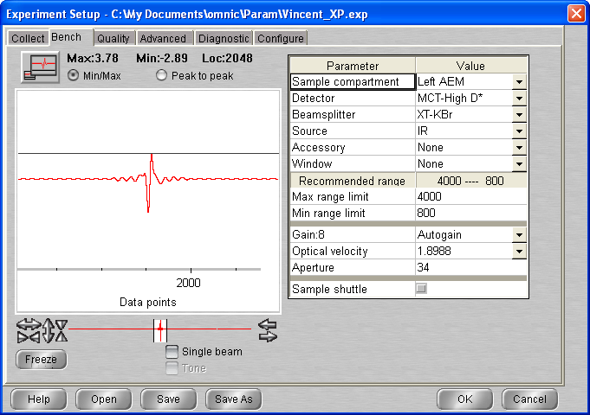

**10:05 ASW_2021_01_25_0031**

512 scans 1 cm-1 res signal 3.79  
p = 1.7 * 10-9

**10:30 ASW_2021_01_25_0032**

512 scans 1 cm-1 res signal 3.79  
p = 1.7 * 10-9

## Annealing to 120K

**11:00 ASW_2021_01_25_0033**

512 scans 1 cm-1 res   
p = 1.7 * 10-9

**11:15 ASW_2021_01_25_0034**

512 scans 1 cm-1 res signal 3.90  
p = 5.9 * 10-9

**11:30 ASW_2021_01_25_0035**

512 scans 1 cm-1 res signal   
p =

**11:45 ASW_2021_01_25_0036**

512 scans 1 cm-1 res signal 3.89  
p = 4.2 * 10-9

## Annealing to 130K

**12:00 ASW_2021_01_25_0037**

512 scans 1 cm-1 res   
p =

**12:15 ASW_2021_01_25_0038**

512 scans 1 cm-1 res signal 3.88  
p =

**12:30 ASW_2021_01_25_0039**

512 scans 1 cm-1 res signal 3.87  
p =

**12:45 ASW_2021_01_25_0040**

512 scans 1 cm-1 res signal 3.87  
p =

## Annealing to 140K

**13:00 ASW_2021_01_25_0041**

512 scans 1 cm-1 res   
p =

**13:15 ASW_2021_01_25_0042**

512 scans 1 cm-1 res signal 3.86  
p =

**13:30 ASW_2021_01_25_0043**

512 scans 1 cm-1 res signal 3.86  
p =

**13:45 ASW_2021_01_25_0044**

512 scans 1 cm-1 res   
p =

## Annealing to 150K

**14:00 ASW_2021_01_25_0045**

512 scans 1 cm-1 res signal 3.86  
p = 7.3 * 10-8

**14:15 ASW_2021_01_25_0046**

512 scans 1 cm-1 res signal 3.85  
p = 4.5 * 10-7

14 :30 Macro 40 scans

## 27/01

11:30 cryo turned off

# Tuesday 09th Feb 2021 (VD)

10:01 Cryo turned on

12:00 Laser On

12:00 MCT Detector cooled

12:57 T = 20.7 P = 5.0 * 10 -10

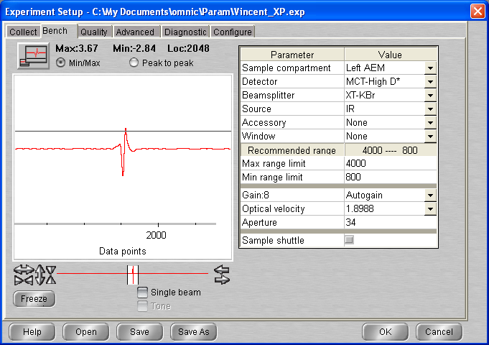

**13:06 BG20210209_01**

512 scans res = 1 cm-1 signal = 3.72  
p = 5.0 10-10 mbar T = 20.7 K

## Deposition #1: H2O @ 20K

13:47 2 min @ 1x10-7 mbar H2O

- Initial Temperature: 20.7 K

- Initial pressure: 5.0 * 10-10 mbar

- Initial gas cell pressure: 7.36 Torr

- Deposition pressure: 1* 10-7 mbar

- Laser signal: 325.3 mV

- Deposition time: 2:00 min

- pressure after deposition: 5.8 * 10-9 mbar

- final gas cell pressure = 7.21 Torr

14:08 Head rotated

14:08 T= 20.7K P= 2.8 10-9

**14:10 ASW_2021_02_09_0001**

512 scans 1 cm-1 res signal 3.80  
p = 1.8 x 10-9 mbar T = 20.7K

**14:30 ASW_2021_02_09_0002**

512 scans 1 cm-1 res signal 3.80  
p = 5.0 x 10-10 mbar T = 20.6K

**14:55 BG20210209_02**

512 scans res = 1 cm-1 signal = 3.72  
p = 5.0 10-10 mbar T = 20.7 K

## Deposition #2: H2O @ 20K

15:15 2 min @ 1x10-7 mbar H2O

- Initial Temperature: 20.7 K

- Initial pressure: 5.0 * 10-10 mbar

- Initial gas cell pressure: 7.19 Torr

- Deposition pressure: 1* 10-7 mbar

- Laser signal: 321.9 mV

- Deposition time: 2:00 min

- pressure after deposition: 6.8 * 10-9 mbar

- final gas cell pressure = 7.04 Torr

15:18 Head rotated

15:18 T= 20.7K P= 3.2 10-9

**15:20 ASW_2021_02_09_0003 (BG1)**

512 scans 1 cm-1 res signal 3.80  
p = 2.4 x 10-9 mbar T = 20.7K

**15:40 ASW_2021_02_09_0004 (BG2)**

512 scans 1 cm-1 res signal 3.79  
p = 5.0 x 10-9 mbar T = 20.7K

**15:58 BG20210209_03**

512 scans res = 1 cm-1 signal = 3.72  
p = 5.0 10-10 mbar T = 20.6 K

## Deposition #3: H2O @ 20K

16:15 2 min @ 1x10-7 mbar H2O

- Initial Temperature: 20.7 K

- Initial pressure: 5.0 * 10-10 mbar

- Initial gas cell pressure: 7.04 Torr

- Deposition pressure: 1* 10-7 mbar

- Laser signal: 323.2 mV

- Deposition time: 2:00 min

- pressure after deposition: 6.8 * 10-9 mbar

- final gas cell pressure = 6.89 Torr

16:18 Head rotated

**16:20 ASW_2021_02_09_0005 (BG1)**

512 scans 1 cm-1 res signal 3.85  
p = 2.5 x 10-9 mbar T = 20.7K

**16:40 ASW_2021_02_09_0006 (BG3)**

512 scans 1 cm-1 res signal 3.85  
p = 5.5 x 10-10 mbar T = 20.7K

**16:55 BG20210209_04**

512 scans res = 1 cm-1 signal = 3.72  
p = 5.0 10-10 mbar T = 20.7 K

## Deposition #4: H2O @ 20K

17:10 2 min @ 1x10-7 mbar H2O

- Initial Temperature: 20.7 K

- Initial pressure: 5.0 * 10-10 mbar

- Initial gas cell pressure: 6.89 Torr

- Deposition pressure: 1* 10-7 mbar

- Laser signal: 324.9 mV

- Deposition time: 2:00 min

- pressure after deposition: 6.5 * 10-9 mbar

- final gas cell pressure = 6.74 Torr

17:16 Head rotated

**17:19 ASW_2021_02_09_0007 (BG1)**

512 scans 1 cm-1 res signal 3.89  
p = 2.1 x 10-9 mbar T = 20.7K

**17:35 ASW_2021_02_09_0008 (BG4)**

512 scans 1 cm-1 res signal 3.89  
p = 6.3 x 10-9 mbar T = 20.7K

**17:50 BG20210209_05**

512 scans res = 1 cm-1 signal = 3.90  
p = 5.0 10-10 mbar T = 20.6 K

## Deposition #5: H2O @ 20K

18:10 2 min @ 1x10-7 mbar H2O

- Initial Temperature: 20.6 K

- Initial pressure: 5.0 * 10-10 mbar

- Initial gas cell pressure: 6.74 Torr

- Deposition pressure: 1* 10-7 mbar

- Laser signal: 324.0 mV

- Deposition time: 2:00 min

- pressure after deposition: 6.5 * 10-9 mbar

- final gas cell pressure = 6.59 Torr

18:13 Head rotated

**18:15 ASW_2021_02_09_0009 (BG1)**

512 scans 1 cm-1 res signal 3.91  
p = 2.4 x 10-9 mbar T = 20.7K

**18:30 ASW_2021_02_09_0010 (BG5)**

512 scans 1 cm-1 res signal 3.91  
p = 7 x 10-10 mbar T = 20.6K

18 :45 Macro 10 scan (all BG1)

LASER OFF

## 10/02

09:52 MCT Cooled

T = 20.6 P = 5 * 10-10 mbar

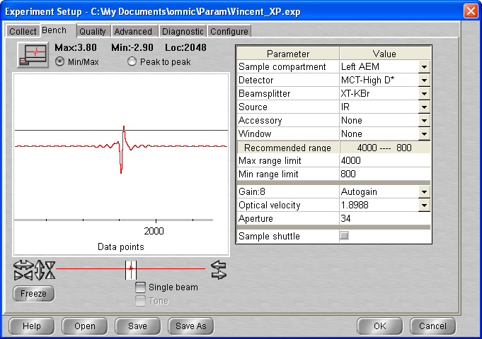

**10:10 ASW_2021_02_09_0021 (BG1)**

512 scans 1 cm-1 res signal 3.80  
p = 5 x 10-10 mbar T = 20.6K

## Annealing to 40 K

|  |  |  |  |
| --- | --- | --- | --- |
| **time** | **File** | Type | signal |
| **10:30** | **_0022** | Warm-up |  |
| **10:45** | **_0023** | Iso1 |  |
| **11:00** | **_0024** | Iso2 | 3.97 |

## Annealing to 60 K

|  |  |  |  |
| --- | --- | --- | --- |
| **time** | **File** | Type | signal |
| **11:15** | **_0025** | Warm-up |  |
| **11:30** | **_0026** | Iso1 |  |
| **11:45** | **_0027** | Iso2 |  |

## Annealing to 80 K

|  |  |  |  |
| --- | --- | --- | --- |
| **time** | **File** | Type | signal |
| **12:00** | **_0028** | Warm-up | 3.93 |
| **12:15** | **_0029** | Iso1 | 3.92 |
| **12:30** | **_0030** | Iso2 | 3.95 |

## Annealing to 100 K

|  |  |  |  |
| --- | --- | --- | --- |
| **time** | **File** | Type | signal |
| **12:45** | **_0031** | Warm-up |  |
| **13:00** | **_0032** | Iso1 | 3.93 |
| **13:15** | **_0033** | Iso2 | 3.93 |

## Annealing to 120 K

|  |  |  |  |
| --- | --- | --- | --- |
| **time** | **File** | Type | signal |
| **13:30** | **_0034** | Warm-up |  |
| **13:45** | **_0035** | Iso1 | 3.92 |
| **14:00** | **_0036** | Iso2 | 3.92 |

## Annealing to 130 K

|  |  |  |  |
| --- | --- | --- | --- |
| **time** | **File** | Type | signal |
| **14:15** | **_0037** | Warm-up |  |
| **14:30** | **_0038** | Iso1 | 3.91 |
| **14:45** | **_0039** | Iso2 |  |
|  | **_0040** | Iso3 |  |
|  | **_0041** |  |  |
|  | **_0042** | Iso3 |  |

## Annealing to 135 K

**_0043**

… To input

16 :00 Macro 20 scan 135K

## 11/02

11 :10 MCT cooled T = 135 P 6.9 * 10-9

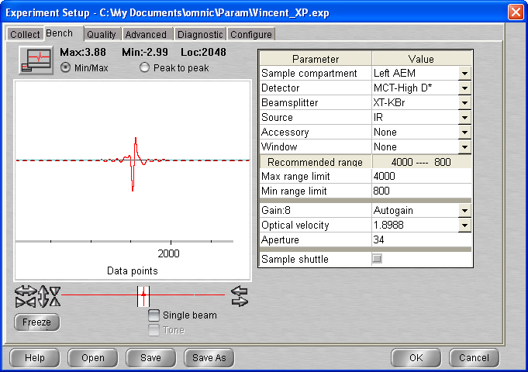

**11:45 ASW_2021_02_09_0064 (BG1)**

512 scans 1 cm-1 res signal 3.90  
p = 6.8 x 10-9 mbar T = 135.0K

**13:15 ASW_2021_02_09_0065(BG1)**

512 scans 1 cm-1 res signal 3.50  
p = 6.7 x 10-9 mbar T = 135.0K

**16:00 ASW_2021_02_09_0066(BG1)**

512 scans 1 cm-1 res signal 3.50  
p = 6.7 x 10-9 mbar T = 135.0K

## 12/02

12 :00 MCT cooled T = 135 P 5.4 * 10-9

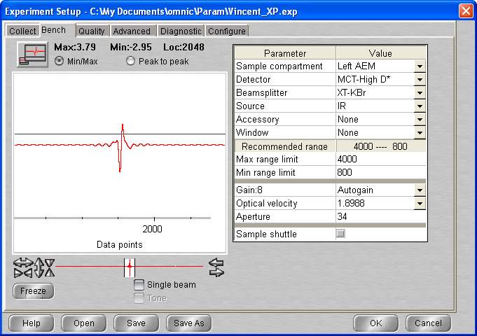

**12:30 ASW_2021_02_09_0067(BG1)**

512 scans 1 cm-1 res signal 3.91  
p = 5.5 x 10-9 mbar T = 135.0K

## Annealing to 137 K

|  |  |  |  |
| --- | --- | --- | --- |
| **time** | **File** | Type | signal |
| **12:45** | **_0068** | Warm-up | 3.92 |
| **13:00** | **_0069** | Iso1 | 3.93 |
| **13:15** | **_0070** | Iso2 | 3.92 |

## Annealing to 138 K

|  |  |  |  |
| --- | --- | --- | --- |
| **time** | **File** | Type | signal |
| **13:30** | **_0071** | Warm-up |  |
| **13:45** | **_0072** | Iso1 | 3.92 |
| **14:00** | **_0073** | Iso2 |  |
| **14:15** | **_0074** | Iso2 |  |
| **14:30** | **_0075** | Iso2 |  |

## Annealing to 140 K

|  |  |  |  |
| --- | --- | --- | --- |
| **time** | **File** | Type | signal |
| **15:00** | **_0076** | Warm-up | 3.90 |
| **15:15** | **_0077** | Iso1 | 3.89 |
| **15:30** | **_0078** | Iso2 | 3.89 |

## Annealing to 145 K

|  |  |  |  |
| --- | --- | --- | --- |
| **time** | **File** | Type | signal |
| **15:45** | **_0079** | Warm-up |  |
| **16:00** | **_0080** | Iso1 |  |
| **16:15** | **_0081** | Iso2 | 3.87 |

## Annealing to 150 K

**16:30 ASW_2021_02_09_0082(BG1)**

512 scans 1 cm-1 res signal 3.87  
p = 8.5 x 10-8 mbar T = 145.0K

16 :45 Macro 20 scans

13/02 14 :50 MCT off / Heater off

# Monday 26th April 2021 (VD)

09:53 T = 278.3 P = 6.8 * 10 -10

09:55 Cryo turned on

11:11 T = 21K P = 5 * 10-10 mbar

11:35 Laser On

11:35 MCT Detector cooled

12:56 T set up at 140 K

13:32 T = 140K p = 4.5 *10-9 mbar

Problem with spectro, cf labbook (solved)

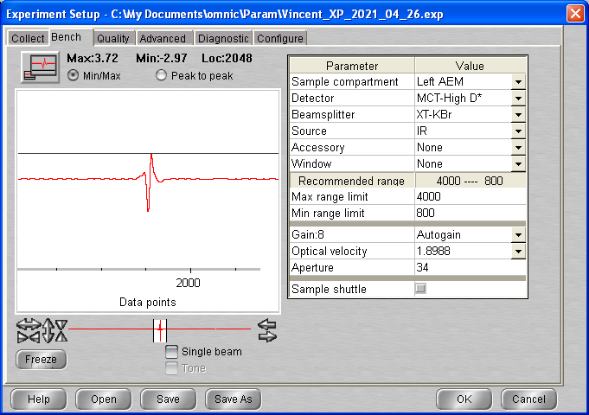

14:14 T = 140.1K p = 2.2 *10-9 mbar

# Background scan(s) #1

**14:20 BG20210426_01**

512 scans res = 1 cm-1 signal = 3.72  
p = 2.1 10-9 mbar T = 140 K

## Deposition #16: H2O @ 140K

14:20 20 min @ 1x10-7 mbar H2O

- Initial Temperature: 140.0 K

- Initial pressure: 1.7 * 10-9 mbar

- Initial gas cell pressure: 7.28 Torr

- Deposition pressure: 1 * 10-7 mbar

- Laser signal: 325.3 mV

- Deposition time: 20 min

- pressure after deposition: 4.3 * 10-8 mbar

- final gas cell pressure = 7.13 Torr

15:08 Laser turned off

15:08 Head rotated

**15:10 ASW_2021_04_26_0001**

512 scans 1 cm-1 res signal 3.70  
p = 2.0 x 10-8 mbar T = 140K

Almost no sample deposited

**16:02 BG20210426_02**

512 scans res = 1 cm-1 signal = 3.69  
p = 2.1 10-9 mbar T = 140 K

16 :10 Laser turned ON

## Deposition #16: H2O @ 140K (1 * 10 -6 deposition pressure)

14:20 2 min @ 1x10-6 mbar H2O

- Initial Temperature: 140.0 K

- Initial pressure: 1.6 * 10-9 mbar

- Initial gas cell pressure: 7.05 Torr

- Deposition pressure: 1 * 10-6 mbar

- Laser signal: 326.5 mV

- Deposition time: 5 min

- pressure after deposition: 1.3 * 10-7 mbar

- final gas cell pressure = 6.63 Torr

17:57 Laser turned off

17:57 Head rotated

**18:00 ASW_2021_04_26_0002**

512 scans 1 cm-1 res signal 3.71  
p = 7.5 x 10-8 mbar T = 140K

18 :15 Macro 20 scans up to scan 22

## 27/04

9:12 MCT Detector cooled

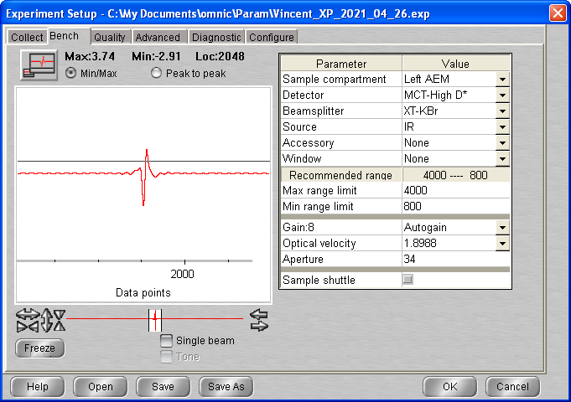

**09:30 ASW_2021_04_26_0023**

512 scans 1 cm-1 res signal 3.75  
p = 1.9 x 10-8 mbar T = 140K

**09:45 ASW_2021_04_26_0024**

512 scans 1 cm-1 res signal 3.75  
p = 1.9 x 10-8 mbar T = 140K

## Annealing to 150 K

**10:00 ASW_2021_04_26_00245**

512 scans 1 cm-1 res signal 3.90  
p = 1.9 x 10-8 mbar T = 140K

10 :15 Macro 5 scans (up to scan 30)

14:11 Heater turned to manual 0 and cryo turned off

# Friday 07th May 2021 (VD)

14:00 Cryo turned on

17:30 Laser On

17:41 MCT Detector cooled

17:54 T = 20.4 P = 5.0 * 10 -10

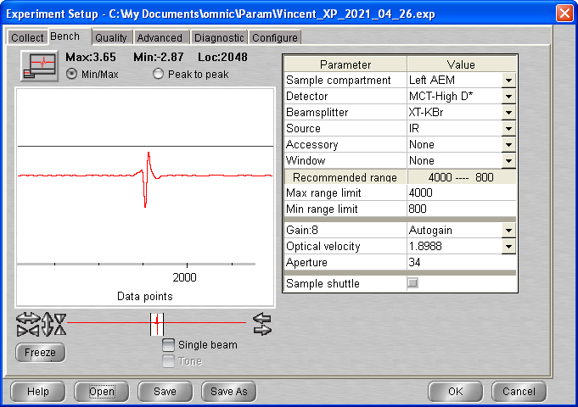

# Background scan(s) #1

**18:20 BG20210507_01**

512 scans res = 1 cm-1 signal = 3.78  
p = 5 10-10 mbar T = 20.4 K

## Deposition #17: H2O @ 20K

14:20 20 min @ 1x10-7 mbar H2O

- Initial Temperature: 20.4 K

- Initial pressure: 5 * 10-5 mbar

- Initial gas cell pressure: 7.54 Torr

- Deposition pressure: 1 * 10-7 mbar

- Laser signal: 324.2 mV

- Deposition time: 20 min

- pressure after deposition: 1.5 * 10-8 mbar

- final gas cell pressure = 6.35 Torr

19:18 Laser turned off

19:19 Head rotated

**19:20 ASW_2021_05_07_0001**

512 scans 1 cm-1 res signal 3.33  
p = 5.2 x 10-9 mbar T = 20.4K

Weired Baseline

19 :35 - Cryo off – START AGAIN TOMORROW (Macro 20 scans)

Clean surface !!

# Friday 08th May 2021 (VD)

12:25 T = 277.9 P = 1.9 * 10-9

12:30 T set up 300K (P rise to 5 * 10-7)

12:56 T = 300 P = 9.2 * 10-9

12:58 heater turn 0 (manual)

13:10 T = 297.3 P = 6.9 e-9

13:10 Cryo ON

14:05 T = 132.5 P = 2.2 * 10-9

14:16 MCT Detector cooled

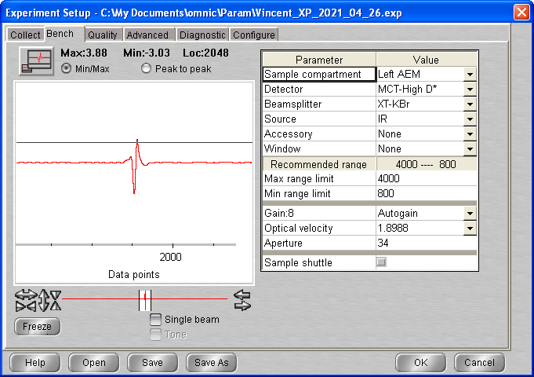

# Background scan(s) #1

**15:35 BG20210508_01**

512 scans res = 1 cm-1 signal = 3.88  
p = 1.6 10-9 mbar T = 20.5 K

15 :21 Laser On

## Deposition #17: H2O @ 20K

16:00 20 min @ 1x10-7 mbar H2O

- Initial Temperature: 20.5 K

- Initial pressure: 1.5 * 10-9 mbar

- Initial gas cell pressure: 7.10 Torr

- Deposition pressure: 1 * 10-7 mbar

- Laser signal: 324.3 mV

- Deposition time: 20 min

- pressure after deposition: 1. * 10-8 mbar

- final gas cell pressure = 5.96 Torr

16:21 Laser turned off

16:22 Head rotated

**16:23 ASW_2021_05_07_0001**

512 scans 1 cm-1 res signal 3.50  
p = 5.4 x 10-9 mbar T = 20.6K

Still weired background … (will try to turn the chamber more before next scan !)

**16:38 ASW_2021_05_07_0002**

512 scans 1 cm-1 res signal 3.52  
p = 3.3 x 10-9 mbar T = 20.5K

**16:53 ASW_2021_05_07_0003**

512 scans 1 cm-1 res signal 3.73  
p = 2.4 x 10-9 mbar T = 20.5K

## Annealing to 100 K

|  |  |  |  |
| --- | --- | --- | --- |
| **time** | **File** | Type | signal |
| **17:15** | **_0004** | Warm-up | 3.71 |
| **17:30** | **_0005** | Iso1 | 3.72 |
| **17:45** | **_0006** | Iso2 |  |

Set up heater at 130 before end of scan 0006

17 :58 Annealing to 130K **ASW_2021_05_07_0007**

Macro 100 scans exit at loop 72 (up to scan 79)

09-05

11:15 MCT Detector cooled

11:15 T = 130.0K P = 4.6*10e-9

11:43

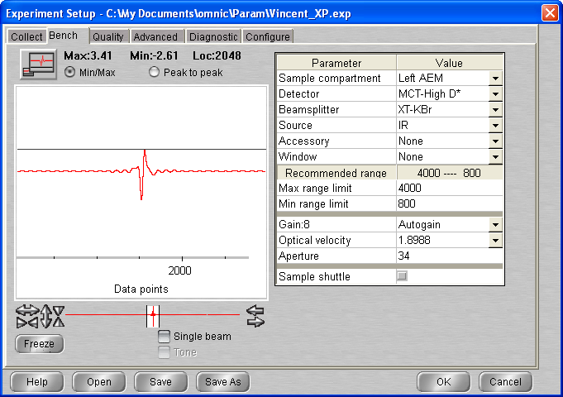

**11:45 ASW_2021_05_07_0080**

512 scans 1 cm-1 res signal 0.75  
p = 4.6 x 10-9 mbar T = 130K

Dodgy Baseline !!! Why ?

(bit of fiddling and ok)

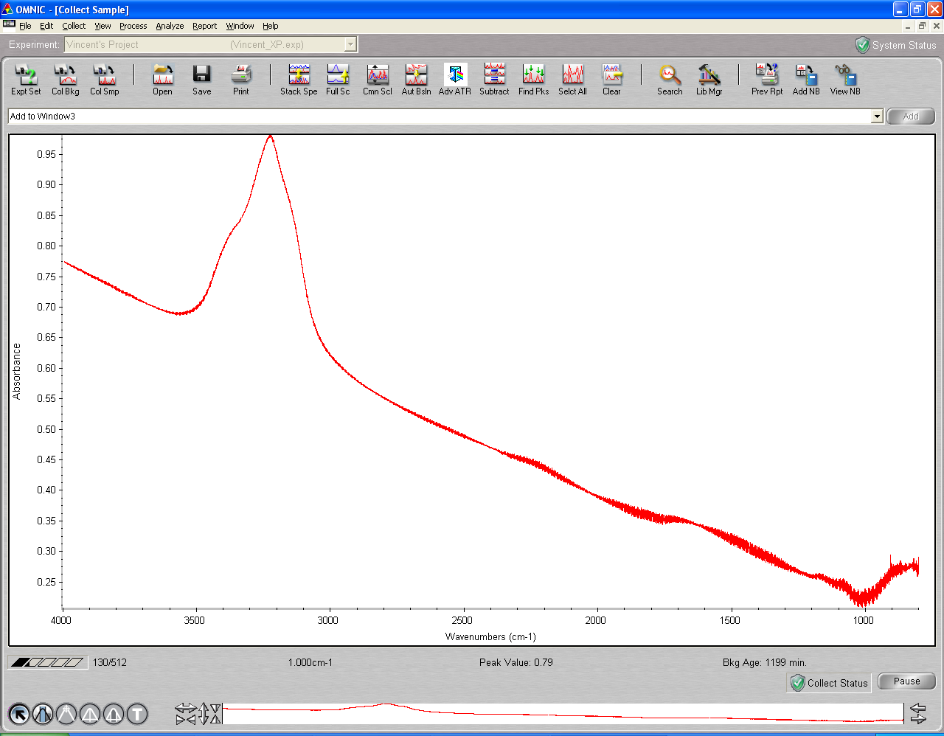

**12:15 ASW_2021_05_07_0081**

512 scans 1 cm-1 res signal 3.13  
p = 4.6 x 10-9 mbar T = 130K

**12:30 ASW_2021_05_07_0082**

512 scans 1 cm-1 res signal 3.0 (2.73 at sart and then increase …)  
p = 4.6 x 10-9 mbar T = 130K

Macro 3 scans (not performed – baseline dodgy again)

Spectro turned off and on again

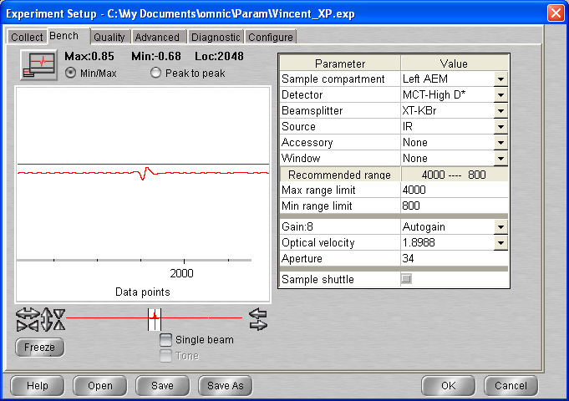

# 11/05/2021

16:53 Compressor turned off, heater on manual 0

# Thursday 13th May 2021 (VD)

10:41 MCT Detector cooled

11:28 Cryo turned on

11:28 Laser On

14:06 T = 20.4 P = 8.3 * 10 -10

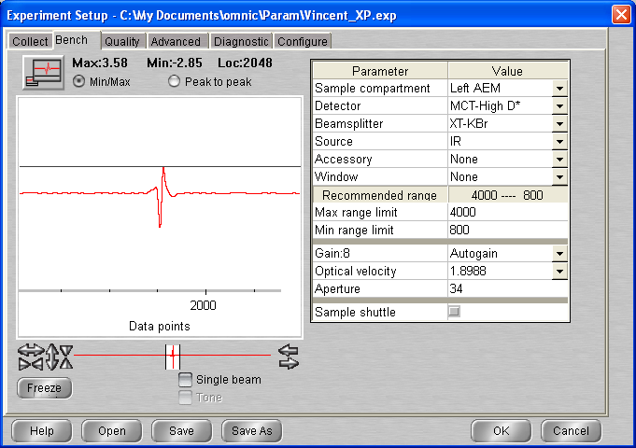

# Background scan(s) #1

**14:10 BG20210513_01**

512 scans res = 1 cm-1 signal = 3.57  
p = 8.2 10-10 mbar T = 20.4 K

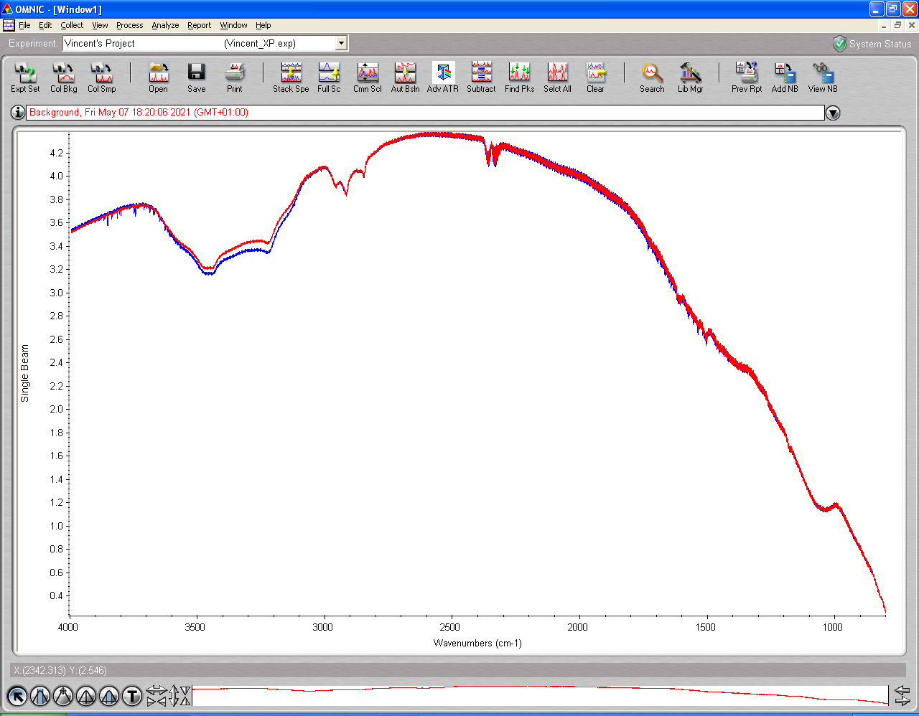

No good background! (blue)

14:24 : cryo stopped

14:25 Heater set up at 300K

15:03 T = 297.5 P start to decrease (from 4.5 * 10-7)

15:05 heater turned off

15:12 T = 290.5 P = 8.0 10-8 Cryo ON

Pressure take long time to go down (probably released lot of crap when warmed up and came down in T too soon)

16:53 T = 20.6 K P = 7.7 * 10-9

**17:00 BG20210513_02**

512 scans res = 1 cm-1 signal = 3.50  
p = 7.5 10-9 mbar T = 20.5 K

Background even worse …

17 :15 Cryo off / Laser off and start again tomorrow …

14/05/2021

10:34 T = 278.1 P = 3.7 * 10-9

10:35 Cryo ON Laser On

12:10 T = 20.4 P = 2.1 * 10-9

12:15 MCT Detector cooled

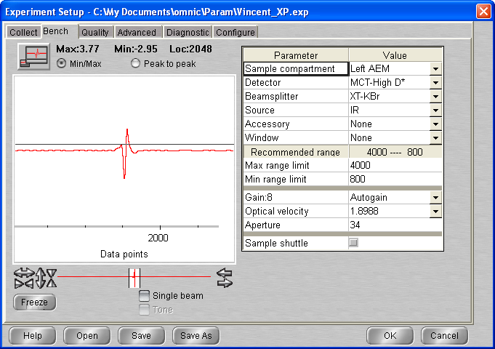

**13:00 BG20210513_03**

512 scans res = 1 cm-1 signal = 3.77  
p = 2.0 10-9 mbar T = 20.3 K

## Deposition #18: H2O @ 20K

13:30 20 min @ 1x10-7 mbar H2O

- Initial Temperature: 20.2 K

- Initial pressure: 1.9 * 10-9 mbar

- Initial gas cell pressure: 6.96 Torr

- Deposition pressure: 1 * 10-7 mbar

- Laser signal: 324.5 mV

- Deposition time: 20 min

- pressure after deposition: 2.2 * 10-8 mbar

- final gas cell pressure = 5.86 Torr

14:00 Laser turned off

14:00 Head rotated

**14:05 ASW_2021_05_13_0001**

512 scans 1 cm-1 res signal 3.70  
p = 8.1 x 10-9 mbar T = 20.3K

**14:40 ASW_2021_05_13_0002**

512 scans 1 cm-1 res signal 3.65  
p = 3.1 x 10-9 mbar T = 20.3K

## Annealing to 70 K

|  |  |  |  |
| --- | --- | --- | --- |
| **time** | **File** | Type | signal |
| **15:00** | **_0003** | Warm-up | 3.64 |
| **15:15** | **_0004** | Iso1 | 3.63 |
| **15:30** | **_0005** | Iso2 | 3.62 |
| **15:45** | **_0006** | Iso3 | 3.61 |

## Annealing to 130 K

|  |  |  |  |
| --- | --- | --- | --- |
| **time** | **File** | Type | signal |
| **16:00** | **_0007** | Warm-up | 3.62 |
| **16:15** | **_0008** | Iso1 | 3.64 |
| **16:30** | **_0009** | Iso2 | 3.65 |
| **16:45** | **_0010** | Iso3 | 3.66 |
| **17:00** | **_0011** | Iso4 | 3.66 |
| **17:15** | **_0012** | Iso5 | 3.66 |
| **17:30** | **_0013** | Iso6 | 3.66 |
| **17:45** | **_0014** | Iso7 | 3.67 |
| **18:00** | **_0015** | Iso8 | 3.67 |
| **18:15** | **_0016** | Iso9 | 3.66 |
| **18:30** | **_0017** | Iso10 | 3.66 |
| **18:45** | **_0018** | Iso11 | 3.66 |
| **19:00** | **_0019** | Iso12 | 3.66 |
| **19:15** | **_0020** | Iso13 | 3.66 |
| **19:30** | **_0021** | Iso14 | 3.66 |
| **19:45** | **_0022** | Iso15 | 3.66 |
| **20:00** | **_0023** | Iso16 | 3.66 |
| **20:15** | **_0024** | Iso17 | 3.66 |
| **20:30** | **_0025** | Iso18 | 3.66 |
| **20:45** | **_0026** | Iso19 | 3.66 |
| **21:00** | **_0027** | Iso20 | 3.66 |
| **21:15** | **_0028** | Iso21 | 3.66 |

16 :50 P = 1.7 * 10-8

18 :40 P = 1.5 * 10-8

20 :00 P = 9.6 * 10-9

21 :15 P = 7.9 * 10-9

21 :30 MCT detector LN2 refill

**21:45 ASW_2021_05_13_0029**

512 scans 1 cm-1 res signal 3.61  
p = 7.5 x 10-9 mbar T = 130K

22 :00 Macro 100 scans

# 15/05/2021

10 :28 Macro in loop 54 (signal = 3.66) T = 130 P = 5.2 * 10-9

11:26 Macro exit loop 58 (signal 3.65) – up to scan 87

11:30 MCT refilled

**11:45 ASW_2021_05_13_0088**

512 scans 1 cm-1 res signal 3.65  
p = 5.2 x 10-9 mbar T = 130K

12 :00 Macro 100 scans

15 :30 P = 4.95 * 10-9

18 :36 P = 4.8 * 10-9 (signal 3.61)

19 :59 🡪 Loop exited (don`t know number – up to scan 123) – compressed air off !!

**20:30 ASW_2021_05_13_0124**

512 scans 1 cm-1 res signal 3.  
p = 4.8 x 10-9 mbar T = 130K

20 :45 Macro 100

16/05

10 :41 Exit at loop 61 (up to scan 208)

Problem with spectro again !!

Computer restarted

**10:55 ASW_2021_05_13_0209**

512 scans 1 cm-1 res signal 3.59  
p = 4.6 x 10-9 mbar T = 130K

**11:15 ASW_2021_05_13_0210**

512 scans 1 cm-1 res signal 3.68  
p = 4.6 x 10-9 mbar T = 130K

**11:30 ASW_2021_05_13_0211**

512 scans 1 cm-1 res signal 3.68  
p = 4.6 x 10-9 mbar T = 130K

**11:45 ASW_2021_05_13_0212**

512 scans 1 cm-1 res signal 3.68  
p = 4.6 x 10-9 mbar T = 130K

**12:00 ASW_2021_05_13_0213**

512 scans 1 cm-1 res signal 3.67  
p = 4.6 x 10-9 mbar T = 130K

**12:15 ASW_2021_05_13_0214**

512 scans 1 cm-1 res signal 3.66  
p = 4.6 x 10-9 mbar T = 130K

12 :30 MCT Detector refilled

**12:45 ASW_2021_05_13_0215**

512 scans 1 cm-1 res signal 3.66  
p = 4.6 x 10-9 mbar T = 130K

13 :00 Macro 100 scans

14 :44 compressed air off again …

14 :46 compressed air on again

14 :57 off again (and on)

19:25 Loop exited at 28

19:33 MCT Detector cooled

**19:45 ASW_2021_05_13_0244**

512 scans 1 cm-1 res signal 3.61  
p = 4.6 x 10-9 mbar T = 130K

20 :00 Macro 100 scans

17/05/2021

12 :22 Macro exited at loop 71 up to scan 315

12:30 MCT Detector refilled

**12:45 ASW_2021_05_13_0316**

512 scans 1 cm-1 res signal 3.65  
p = 4.5 x 10-9 mbar T = 130K

13 :00 Macro 100 scans

16 :04 Compressor off

Exit loop 28 (up to scan )

**19:45 ASW_2021_05_13_0345**

512 scans 1 cm-1 res signal 3.65  
p = 4.2 x 10-9 mbar T = 130K

20 :00 Macro 100 scan exit at loop 67 (up to scan )

**11:45 ASW_2021_05_13_0413**

512 scans 1 cm-1 res signal 3.69  
p = 3.6 x 10-9 mbar T = 130K

**12:15 ASW_2021_05_13_0414**

512 scans 1 cm-1 res signal 3.68  
p = 3.5 x 10-9 mbar T = 130K

Macro 100 scans exit at loop 30 (19 : 15) up to scan 444

**19:45 ASW_2021_05_13_0445**

512 scans 1 cm-1 res signal 3.63  
p = 3.5 x 10-9 mbar T = 130K

Macro 100 scans

19/05/2021

11 :21 Exit at loop 67 up to scan

**11:45 ASW_2021_05_13_0513**

512 scans 1 cm-1 res signal 3.72  
p = 3.0 x 10-9 mbar T = 130K

12 :00 Macro 100 scans (exit at loop 28 – scan 541)

**18:45 ASW_2021_05_13_0542**

512 scans 1 cm-1 res signal 3.63  
p = 2.8 x 10-9 mbar T = 130K

19 :00 Macro 100 scans (exit at loop 71 20/05 11:19)

Up to scan 🡪 613 (last one not good signal)

**11:45 ASW_2021_05_13_0614**

512 scans 1 cm-1 res signal 3.80  
p = 2.5 x 10-9 mbar T = 130K

12 :00 Macro 100 scans

Exited at loop 28

**18:45 ASW_2021_05_13_0643**

512 scans 1 cm-1 res signal 3.79  
p = 2.5 x 10-9 mbar T = 130K

19 :00 Macro 100 scan (exited at loop 74 up to scan 717)

**12:45 ASW_2021_05_13_0718**

512 scans 1 cm-1 res signal 3.63  
p = 2.4 x 10-9 mbar T = 130K

13 :00 Macro 100 scans (exit at loop 28 up to scan 746)

19:34 MCT Detector cooled

**19:45 ASW_2021_05_13_0747**

512 scans 1 cm-1 res signal 3.73  
p = 2.4 x 10-9 mbar T = 130K

20 :00 Macro 100 scan exit loop 67 up to scan 814

11:37 MCT Detector cooled

**11:45 ASW_2021_05_13_0815**

512 scans 1 cm-1 res signal 3.62  
p = 2.3 x 10-9 mbar T = 130K

Macro 100 scans exit at loop 15 up to scan

**15:30 ASW_2021_05_13_0831**

512 scans 1 cm-1 res signal 3.63  
p = 2.4 x 10-9 mbar T = 130K

## Warm up to 140K

**15:45 ASW_2021_05_13_0832**

512 scans 1 cm-1 res signal 3.63  
p = 2.4 x 10-9 mbar T = 130K

**16:00 ASW_2021_05_13_0833**

512 scans 1 cm-1 res signal 3.63  
p = 2.5 x 10-8 mbar T = 140K

**16:15 ASW_2021_05_13_0834**

512 scans 1 cm-1 res signal 3.63  
p = 2.5 x 10-8 mbar T = 140K

**16:30 ASW_2021_05_13_0835**

512 scans 1 cm-1 res signal 3.63  
p = 2.5 x 10-8 mbar T = 140K

**16:45 ASW_2021_05_13_0836**

512 scans 1 cm-1 res signal 3.63  
p = 2.4 x 10-8 mbar T = 140K

**17:00 ASW_2021_05_13_0837**

512 scans 1 cm-1 res signal 3.63  
p = 2.3 x 10-8 mbar T = 140K

**17:15 ASW_2021_05_13_0838**

512 scans 1 cm-1 res signal 3.62  
p = 2.3 x 10-8 mbar T = 140K

**17:30 ASW_2021_05_13_0839**

512 scans 1 cm-1 res signal 3.62  
p = 2.3 x 10-8 mbar T = 140K

**17:45 ASW_2021_05_13_0840**

512 scans 1 cm-1 res signal 3.62  
p = 2.3 x 10-8 mbar T = 140K

**18:00 ASW_2021_05_13_0841**

512 scans 1 cm-1 res signal 3.62  
p = 2.2 x 10-8 mbar T = 140K

**18:15 ASW_2021_05_13_0842**

512 scans 1 cm-1 res signal 3.63  
p = 2.2 x 10-8 mbar T = 140K

## Warm up to 142K

**18:30 ASW_2021_05_13_0843**

512 scans 1 cm-1 res signal 3.63  
p = 2.4 x 10-8 mbar T = 140K

**18:45 ASW_2021_05_13_0844**

512 scans 1 cm-1 res signal 3.63  
p = 3.8 x 10-8 mbar T = 142 K

19 :00 Macro 8 scans (exit loop 2)

**19:30 ASW_2021_05_13_0847**

512 scans 1 cm-1 res signal 3.63  
p = 3.7 x 10-8 mbar T = 142K

**19:45 ASW_2021_05_13_0848**

512 scans 1 cm-1 res signal 3.63  
p = 3.7 x 10-8 mbar T = 142K

**20:00 ASW_2021_05_13_0849**

512 scans 1 cm-1 res signal 3.63  
p = 3.6 x 10-8 mbar T = 142K

**20:15 ASW_2021_05_13_0850**

512 scans 1 cm-1 res signal 3.64  
p = 3.6 x 10-8 mbar T = 142K

**20:30 ASW_2021_05_13_0851**

512 scans 1 cm-1 res signal 3.64  
p = 3.6 x 10-8 mbar T = 142K

**20:45 ASW_2021_05_13_0852**

512 scans 1 cm-1 res signal 3.64  
p = 3.6 x 10-8 mbar T = 142K

**21:00 ASW_2021_05_13_0853**

512 scans 1 cm-1 res signal 3.63  
p = 3.6 x 10-8 mbar T = 142K

## Warm up to 145K

**21:15 ASW_2021_05_13_0854**

512 scans 1 cm-1 res signal 3.63  
p = 3.6 x 10-8 mbar T = 142K

**21:30 ASW_2021_05_13_0855**

512 scans 1 cm-1 res signal 3.63  
p = 7.8 x 10-8 mbar T = 145K

**21:45 ASW_2021_05_13_0856**

512 scans 1 cm-1 res signal 3.63  
p = 7.8 x 10-8 mbar T = 145K

**22:00 ASW_2021_05_13_0857**

512 scans 1 cm-1 res signal 3.63  
p = 7.8 x 10-8 mbar T = 145K

**22:15 ASW_2021_05_13_0858**

512 scans 1 cm-1 res signal 3.63  
p = 7.8 x 10-8 mbar T = 145K

**22:30 ASW_2021_05_13_0859**

512 scans 1 cm-1 res signal 3.62  
p = 7.9 x 10-8 mbar T = 145K

**22:45 ASW_2021_05_13_0860**

512 scans 1 cm-1 res signal 3.62  
p = 7.9 x 10-8 mbar T = 145K

**23:00 ASW_2021_05_13_0861**

512 scans 1 cm-1 res signal 3.62  
p = 7.9 x 10-8 mbar T = 145K

## Warm up to 150K

**23:15 ASW_2021_05_13_0862**

512 scans 1 cm-1 res signal 3.61  
p = 7.9 x 10-8 mbar T = 145K

**23:30 ASW_2021_05_13_0863**

512 scans 1 cm-1 res signal 3.61  
p = 2.8 x 10-7 mbar T = 150K

23 :45 Macro 8 scans up to scan 871

23/05/2021

12:20 Cryo off – Heater manual 0

# Monday 24th May 2021 (VD)

10:10 T = 280.5 P = 2.90 * 10-9

10:10 Cryo turned on / Laser On

11:00 T = 134.7 P= 1.8 * 10-9

11:26 MCT Detector cooled

11:26 T = 22.2 P=1.3 * 10-9

12:20 T = 20.3 P= 1.26 * 10-9

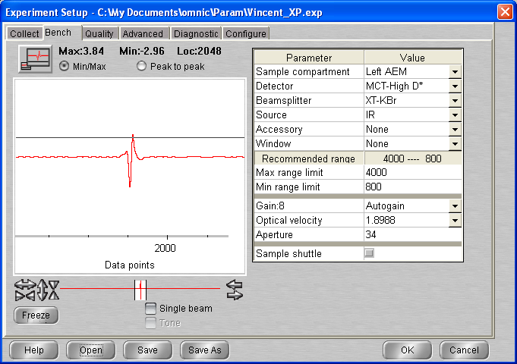

# Background scan(s) #1

**12:51 BG20210524_01**

512 scans res = 1 cm-1 signal = 3.86  
p = 1.2 10-9 mbar T = 20.3 K

## Deposition #19: H2O @ 20K

13:15 20 min @ 1x10-7 mbar H2O

- Initial Temperature: 20.3 K

- Initial pressure: 1.2 * 10-9 mbar

- Initial gas cell pressure: 7.34 Torr

- Deposition pressure: 1 * 10-7 mbar

- Laser signal: 326.3 mV

- Deposition time: 20 min

- pressure after deposition: 1.8 * 10-8 mbar

- final gas cell pressure = 6.22 Torr

13:35 Laser turned off

13:35 Head rotated

**13:40 ASW_2021_05_24_0001**

512 scans 1 cm-1 res signal 3.66  
p = 6 x 10-9 mbar T = 20.3K

**14:00 ASW_2021_05_24_0002**

512 scans 1 cm-1 res signal 3.66  
p = 2.8 x 10-9 mbar T = 20.3K

**14:30 ASW_2021_05_24_0003**

512 scans 1 cm-1 res signal 3.65  
p = 2.0 x 10-9 mbar T = 20.3K

## Annealing to 70 K

|  |  |  |  |
| --- | --- | --- | --- |
| **time** | **File** | Type | signal |
| **14:45** | **_0004** | Warm-up | 3.65 |
| **15:00** | **_0005** | Iso1 | 3.63 |
| **15:15** | **_0006** | Iso2 | 3.63 |
| **15:30** | **_0007** | Iso3 | 3.63 |

## Annealing to 130 K

**15:45 ASW_2021_05_24_0008**

512 scans 1 cm-1 res signal 3.66  
p = 4.4 x 10-9 mbar T = 70K

**16:00 ASW_2021_05_24_0009**

512 scans 1 cm-1 res signal 3.66  
p = 6.5 x 10-8 mbar T = 133.5K

**16:15 ASW_2021_05_24_0010**

512 scans 1 cm-1 res signal 3.67  
p = 7.2 x 10-8 mbar T = 135K

**16:30 ASW_2021_05_24_0011**

512 scans 1 cm-1 res signal 3.68  
p = 5.5 x 10-8 mbar T = 135K

**16:45 ASW_2021_05_24_0012**

512 scans 1 cm-1 res signal 3.68  
p = 3.7 x 10-8 mbar T = 135K

**17:00 ASW_2021_05_24_0013**

512 scans 1 cm-1 res signal 3.68  
p = 3.0 x 10-8 mbar T = 135K

**17:15 ASW_2021_05_24_0014**

512 scans 1 cm-1 res signal 3.69  
p = 2.6 x 10-8 mbar T = 135K

**17:30 ASW_2021_05_24_0015**

512 scans 1 cm-1 res signal 3.69  
p = 2.4 x 10-8 mbar T = 135K

**17:45 ASW_2021_05_24_0016**

512 scans 1 cm-1 res signal 3.69  
p = 2.3 x 10-8 mbar T = 135K

18 :00 MCT Detector refilled

(compressor off …)

**18:15 ASW_2021_05_24_0017**

512 scans 1 cm-1 res signal 3.67  
p = 2.2 x 10-8 mbar T = 135K

18 :30 Macro 100 scans (exited at loop 70 🡪 up to scan 87)

10:45 MCT Detector cooled

**11:00 ASW_2021_05_24_0088**

512 scans 1 cm-1 res signal 3.78  
p = 9.6 x 10-9 mbar T = 135K

**11:15 ASW_2021_05_24_0089**

512 scans 1 cm-1 res signal 3.79  
p = 9.5 x 10-9 mbar T = 135K

11 :30 Macro 100 scans exit at loop 29 up to scan 118

18:15 MCT detector refilled

**18:30 ASW_2021_05_24_0119**

512 scans 1 cm-1 res signal 3.66  
p = 8.7 x 10-9 mbar T = 135K

**18:45 ASW_2021_05_24_0120**

512 scans 1 cm-1 res signal 3.66  
p = 8.7 x 10-9 mbar T = 135K

19 :00 Macro 100 scan exit at loop 68 up to scan 188

**11:00 ASW_2021_05_24_0189**

512 scans 1 cm-1 res signal 3.70  
p = 8.0 x 10-9 mbar T = 135K

**11:15 ASW_2021_05_24_0190**

512 scans 1 cm-1 res signal 3.69  
p = 8.0 x 10-9 mbar T = 135K

11 :30 Macro 100 exit at loop 30 up to scan 220

**18:45 ASW_2021_05_24_0221**

512 scans 1 cm-1 res signal 3.69  
p = 8.0 x 10-9 mbar T = 135K

19 :00 Macro 100 scan exit at loop 71 up to scan 292

27/05

**11:45 ASW_2021_05_24_0293**

512 scans 1 cm-1 res signal 3.69  
p = 7.5 x 10-9 mbar T = 135K

12 :00 Macro exited at loop 28 – up to scan 321

**18:45 ASW_2021_05_24_0322**

512 scans 1 cm-1 res signal 3.65  
p = 7.4 x 10-9 mbar T = 135K

19 :00 Macro 100 exit at loop 68 up to scan 390

10:50 MCT Detector cooled

**11:00 ASW_2021_05_24_0391**

512 scans 1 cm-1 res signal 3.70  
p = 7.2 x 10-9 mbar T = 135K

**11:15 ASW_2021_05_24_0392**

512 scans 1 cm-1 res signal 3.70  
p = 7.2 x 10-9 mbar T = 135K

## Warm up to 140K

**11:30 ASW_2021_05_13_0393**

512 scans 1 cm-1 res signal 3.70  
p = 7.2 x 10-9 mbar T = 135K

**11:45 ASW_2021_05_13_0394**

512 scans 1 cm-1 res signal 3.70  
p = 2.5 x 10-8 mbar T = 140K

**12:00 ASW_2021_05_13_0395**

512 scans 1 cm-1 res signal 3.70  
p = 2.6 x 10-8 mbar T = 140K

**12:15 ASW_2021_05_13_0396**

512 scans 1 cm-1 res signal 3.70  
p = 2.6 x 10-8 mbar T = 140K

**12:30 ASW_2021_05_13_0397**

512 scans 1 cm-1 res signal 3.69  
p = 2.6 x 10-8 mbar T = 140K

**12:45 ASW_2021_05_13_0398**

512 scans 1 cm-1 res signal 3.69  
p = 2.6 x 10-8 mbar T = 140K

**13:00 ASW_2021_05_13_0399**

512 scans 1 cm-1 res signal 3.69  
p = 2.6 x 10-8 mbar T = 140K

Compressor issues

**13:15 ASW_2021_05_13_0400**

512 scans 1 cm-1 res signal 3.73  
p = 2.6 x 10-8 mbar T = 140K

13 :30 Macro 100 exit at loop 17 up to scan 417

**17:30 ASW_2021_05_13_0418**

512 scans 1 cm-1 res signal 3.73  
p = 2.6 x 10-8 mbar T = 140K

## Warm up to 145K

**17:45 ASW_2021_05_13_0419**

512 scans 1 cm-1 res signal 3.68  
p = 2.5 x 10-8 mbar T = 140K

**18:00 ASW_2021_05_13_0420**

512 scans 1 cm-1 res signal 3.67  
p = 9 x 10-8 mbar T = 145K

**18:15 ASW_2021_05_13_0421**

512 scans 1 cm-1 res signal 3.67  
p = 9.1 x 10-8 mbar T = 145K

18 :30 MCT Detector refilled

**18:45 ASW_2021_05_13_0422**

512 scans 1 cm-1 res signal 3.67  
p = 9.3 x 10-8 mbar T = 145K

19 :00 Macro 100 scans exit at loop 77 up to scan 499

29/05 13: 00 Cryo off, heater off

# End

# General info

## Omnic save

Omnic Autosave file location: C:\My Documents\omnic\Autosave

## Temperature controller

### To set the temperature:

Press [SET] + {RAISE/LOWER] to enter the desire pressure in Kelvin; then press [AUTO]

### To turn off heater (not the controller):

Press [MAN] under ‘Heater’ + [RAISE/LOWER] to reduce the heater voltage to 0.0 V

### PID values

P = 2.5 I = 5.0 D = 0.0

Questions ?

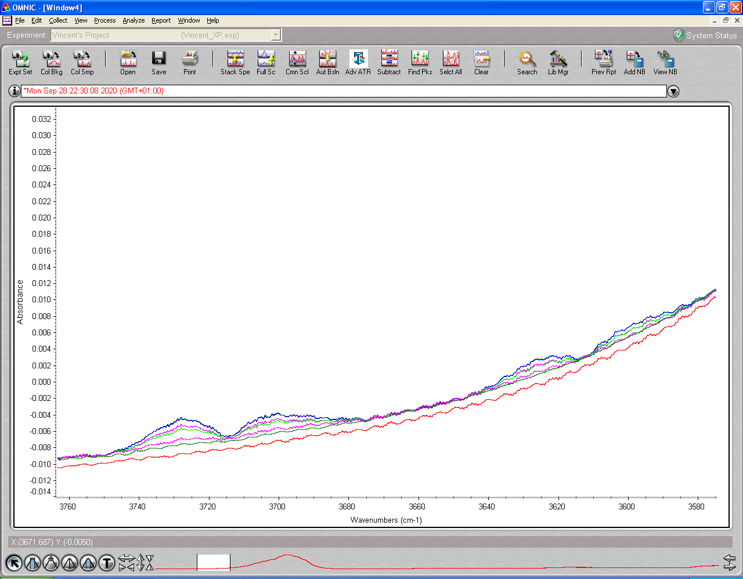

Dangling bonds * 2 or CO2 signature

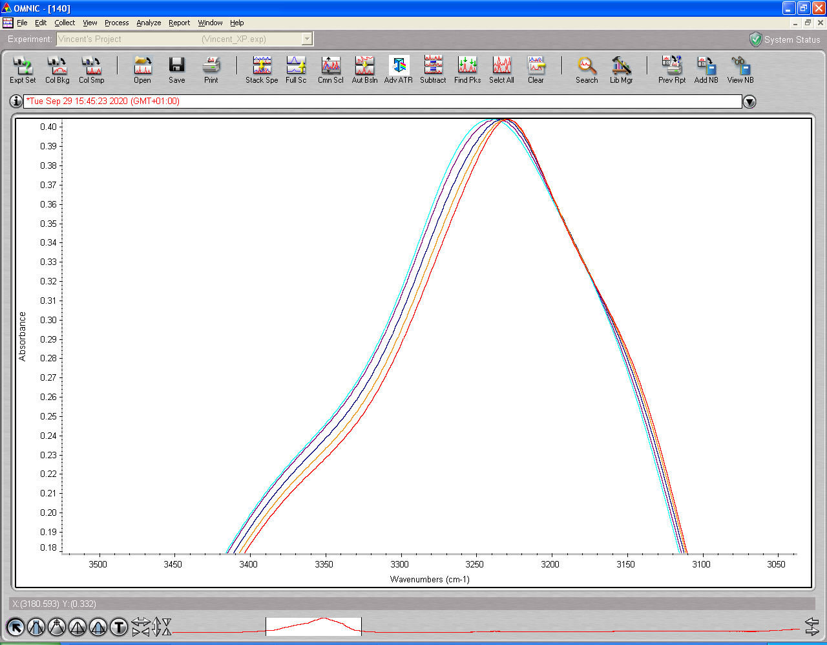

# DATA Processing

## 16-09

All Isotherms scans (3rd) – smoothed and auto baseline corrected

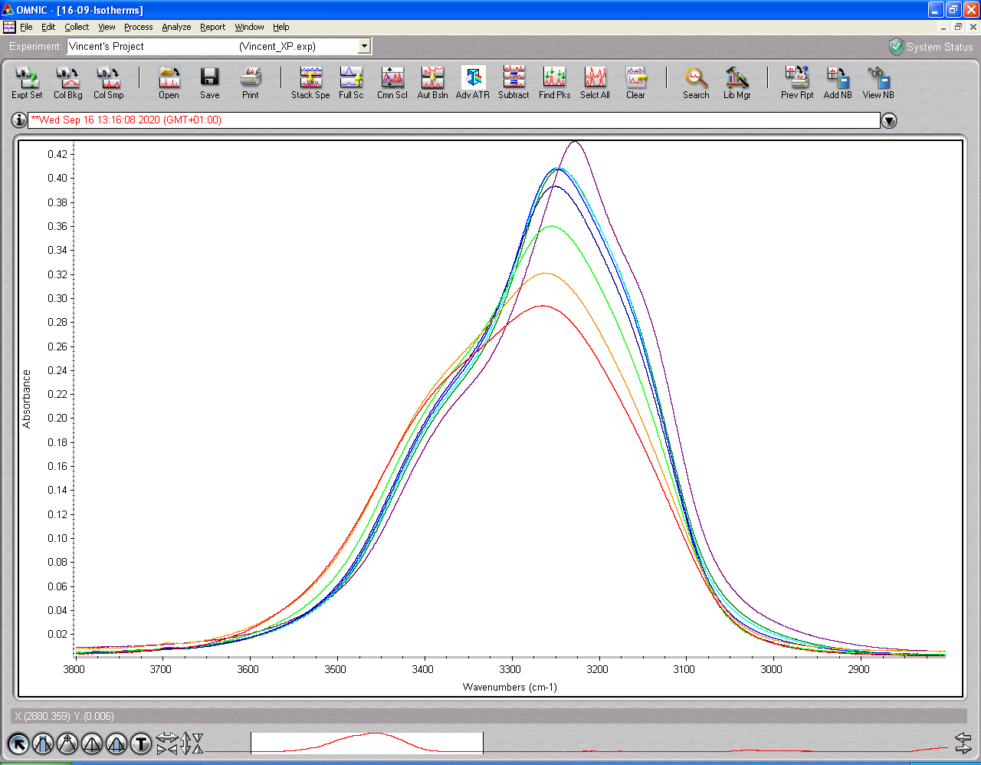

## 28-09

All Isotherms scans (4th) – smoothed and auto baseline corrected

